THE INTERROGATION OF PALESTINIANS DURING THE INTIFADA:

FOLLOW UP TO MARCH 1991 B'TSELEM REPORT

Jerusalem, March 1992
Writen by:
Stanley Cohen & Daphna Golan

Acknowledgements:
We are graeteful for the help we received from many individuals and organizations:
- To the Public Committee Against Torture in Israel and especially Hanna Friedman for general co-operation in preparing this report;
- To other Israeli, Palestinian and international human rights organizations for information;
- To Bassem 'Eid for helping in interviewing and translating;
- To Atty. Tamar Pelleg-Sryck for information about detainees in Gaza;
- To Jessica Bonn, Yael Ungar, Nurit Wald and Hila Waldman for help in editing and translating.
- B'Tselem would also like to thank Caroline Borup-Jorgensen for editing the English Internet version of the report.

In the past, the interrogator would say to me "Look. He got a bruise from the door frame. Write that he has redness. Redness, not swelling." Now I don't write that any more. I'm not going to be a sucker. Not from goodness of heart, it's just that I'm watching out for myself.

- Army medical orderly (reservist), February 5, 1992, when Mustafa 'Akawi's death in prison became known.
Table of Contetns:

1. SUMMARY OF ORIGINAL REPORT 5
2. REACTIONS BY PUBLIC AND MEDIA 8
(a) Israel () 8
(b) International 12
3. OFFICIAL INVESTIGATIONS 13
(a) Knesset and Knesset Committees 13
(b) Inquiry by IDF - (" Vardi Inquiry") 14
(c) Joint Ministry of Justice and GSS Committee 18
(d) Internal GSS Controller 20
(e) State Comptroller's Report 20
(f) Visit of Members of the Jerusalem City Council to the Russian Compound Prison 20
4. OTHER RELEVANT DEVELOPMENTS 22
(a) Petition to High Court by PCATI 22
(b) Statement by ICRC 24
(c) Government Ratification of Convention Against Torture 24
d Police Interrogations in Jerusalem 27
(e) Petition to the High Court by the Association for Civil Rights in Israel (ACRI) 28
(f) Other Legal Developments 30
5. FURTHER ALLEGATIONS ABOUT TORTURE AND ILL-TREATMENT 31
(a) Follow-up on those interviewed for 1991 Report 31
(b) Reports from other human rights organizations 34
(c) Media Reports 36
(d) Current Patterns and Allegations 38
(e) Death in Interrogation: Mustafa 'Akawi 47
6. CONCLUSIONS AND RECOMMENDATIONS 52
APPENDIX I: Arie Shavit, "Twelve Days on Gaza Beach," 55
APPENDIX II: Extracts from Testimony of Ayman 'Awad to IDF Inquiry 56
APPENDIX III: Charge Sheet No. 1 against the Police Investigators in Jerusalem 59

1. SUMMARY OF ORIGINAL REPORT

In March 1991, B'tselem published a 150-page report: The Interrogation of Palestinians During the Intifada: Ill-treatment, "Moderate Physical Pressure" or Torture ? (hereinafter "the report")

The main part of the Report ["Research Findings" pp. 45 - 104] is based on interviews with 41 adult male Palestinians who had been interrogated during the previous year, mainly by the General Security Services (GSS) but also the IDF. and the police. These 41 interviewees were located from a list of 60 names (provided by lawyers and human rights organizations) of Palestinians who had alleged some ill-treatment during their interrogation. (The remaining 19 on the list declined to co-operate in the research, did not appear for the interviews or gave testimonies which we judged too incomplete or unreliable to be used).

Of the 41 interviewees, 29 were from the West Bank and 12 from Gaza. 26 out of the total had been recently released and 15 were still under detention. The released detainees were given detailed interviews (in Arabic) in their homes; the detainees still under detention testified in affidavits taken by lawyers. Between them, the group had been interrogated in 10 different detention centers or prisons in the Occupied Territories. Where possible, claims were checked from independent sources, such as medical reports.

The modal period of interrogation ranged from 10 to 18 days. There was a clear, consistent and routine pattern in the methods of interrogation used. Virtually everyone in the group were subjected to the following 10 methods : (i) verbal insults and abuse; (ii) threats to harm the detainee or his family members; (iii) sleep and food deprivation (sometimes up to 10 days with virtually no sleep); (iv) "hooding," that is, covering the head with a sack (sometimes wet) for several hours on end ; (v) prolonged periods of painful confinement crouched in small cells (the "closet" or "refrigerator"); (vi) being tied-up for long periods (in one case, for 36 hours) in deliberately painful positions, (for example the "banana" where the body is bent backwards, with hands tied to legs) or - the standard technique for nearly all detainees - "al-Shabah" (being tied, with hands bound over the head, sometimes to a wall attachment, for hours or even days); (vii) the use of collaborators to extract information either by violence or threats of violence; (viii) forced physical exercise; (vix) cold showers and enforced sitting on a wet floor for prolonged periods; (x) severe beatings on all parts of the body with fists, sticks and other instruments (as a direct result of beatings, 15 of the sample lost consciousness and 11 were injured so severely that they had to be treated, even in hospitals outside the detention center).

The Report gives detailed descriptions of these separate techniques, which are usually used in combination: for example, prolonged sleep deprivation, threats of injury, long periods of being tied up in a confined space with a sack over the head interspersed with beating. Some techniques are illustrated with sketches based on the interviewees' descriptions. The full accounts of 7 individuals (2 from Gaza and 5 from the West Bank) are reproduced to show typical sequences of interrogation.

Not one of the 41 interviewees was found guilty or even suspected of the type of "hostile terorist activity" for which the official Landau Commission [see below] justified the used of "moderate physical pressure." Of the 26 released detainees, in fact only 12 were eventually charged after their interrogation and 3 had been placed in administrative detention (that is, detention without trial). The other 11 were released without being charged. Of 15 detainees still in prison, 4 were under administrative detention orders and 5 were still awaiting trial. That is, of the total 41 interviewees, 23 were charged, none for serious offences involving violence. The average length of imprisonment was about the same as the time spent in detention waiting trial.

No correlation was found between the intensity of the interrogation and the seriousness of the offence or whether the suspect was eventually charged. Everyone interviewed was subject to some form of ill-treatment. All except one were physically beaten. There was no evidence indicating the use of special implements for inflicting pain or for the use of electric shock.

The methods of interrogation revealed by our enquiry are both prohibited by international declarations and conventions and by Israeli law. These prohibitions are reviewed in the introductory section of the Report (pp. 9 - 21). Israel is committed to international conventions against torture and "cruel and inhuman punishment" : defined as the intentional infliction of pain and suffering - mental or physical - in order to extract confessions or information. This commitment is fully reflected in the Israeli criminal code. There are clear and specific laws against the use of force by public servants for such purposes as extracting confessions. GSS agents (like the Israeli police or soldiers) are fully subject to these laws. There are also formal limitations to the admissability in court of evidence obtained by force.

The Report argues, though, that the administration of military justice in the Occupied Territories, particularly in the previous three years of the intifada, undermines these protections and prohibitions available in the legal system and required by international human rights law. Three particularly important problems are reviewed. First, the long period of incommunicado detention without access to a lawyer (usually for a period of 30 days); second, the wide powers given to the GSS and the high prestige it enjoys without a corresponding framework of public accountability or scrutiny; third, the difficulty of challenging confessions in court. Such conditions create a situation in which the ill-treatment of detainees can go unchecked and can become routine. Existing legal controls and mechanisms of complaint were found (pp. 97 - 104) to be inadequate. In not a single case, did the military judges use their authority to place the restrictions on the GSS whether by allowing access to a lawyer, limiting the period of detention or querying the status of a confession.

The Report also points to the wider political and legal conditions which allow for abuses during the interrogation of Palestinians. In this context, the controversial 1987 Landau Commission report is reviewed and criticized (pp 22 - 31). The Commission established that GSS agents had systematically lied to the courts for 16 years about using force to extract confessions. Though condemning this practice of perjury, the Commission went on to justify the use of "moderate physical pressure" as a method of interrogation. The B'tselem report rejects the Commission's legal and moral claims that "moderate physical pressure" is justified (for example, by the defence of "necessity"), is quite different from torture or is allowed by international and Israeli law.

We point to the grave implications of this removal of the sanctions against force - a removal achieved not by legal change, but by administrative directives contained in a secret set of "guidelines" implicitly directed only at the interrogation of Palestinians. First, by weakening the absolute moral taboo against torture, the Commission opened the way for interrogation practices which cannot be allowed in any democratic society. Second, by placing its "guidelines" for approved forms of "moderate physical pressure" in a secret, unpublished report, the public cannot know what measures are being permitted in its name. This also widens the net of secrecy; we describe the likely knowledge and complicity of others (such as prison staff, police, soldiers, judges, doctors) in human rights abuses or their concealment.

The B'tselem report acknowledges the difficulty of obtaining valid and reliable information about ill-treatment or torture during interrogation. The credibility of victims can be questioned; testimonies are subject to exaggeration and inaccuracy, either unintentionally or deliberately to discredit the authorities. We cannot vouch for every detail of the evidence presented in the Report. We are convinced, however, that the detailed internal consistency in our interviews, backed up sometimes by external evidence such as medical certification, together with information from other human rights organizations and lawyers (reviewed on pp. 32 - 44), reveal beyond any reasonable doubt an accurate picture of the interrogation experience of this particular group of detainees. Using the most conservative possible figures, we estimate (p.107) that some 1,500 - 2,000 Palestinians went through some permutation of these interrogation methods in each of the first three years of the intifada, 1988 - 1990. During the research for this follow-up Report we realized that this figure is a serious underestimate. The number was closer to 5,000 each year.

By formal criteria, these methods - particularly when used together over prolonged periods - fit accepted international definitions of "torture." Even if the Israeli government refuses to acknowledge that such definitions apply, then these methods are self evidently forms of ill-treament, abuse or "cruel and inhuman treatment." And to call these methods "moderate physical pressure" does not make them acceptable by the international human rights standards to which Israel is committed.

The Report concludes (pp 109 - 112) with ten policy recommendations aimed at reducing the conditions under which violations can occur. These include: making public the secret part of the Landau Report; abolishing the period of incommunicado detention - or at least reducing it by applying Israeli law which requires suspects to be brought before a judge within 48 hours; allowing detainees easier and quicker access to lawyers; only admitting as evidence testimonies made in Arabic; establishing a clear hierarchy for supervision of GSS investigations and the setting up an independent, external body to deal with individual complaints and allegations.

2. REACTIONS BY PUBLIC AND MEDIA

(a) Israel ()

The Report and the press conference announcing its publication (21 March,1991) received immediate and extensive attention in the Israeli media and public. The Israeli television and radio news covered the press conference and the Report was summarized in all the Hebrew daily papers.() The mass circulation weekly papers gave the most detailed coverage - reprinting extracts from testimonies, describing interrogation methods and reproducing the drawings.()

This coverage was, in our opinion, sympathetic and fair. Numerous editorials and articles in the first weeks after the Report was published appeared expressing concern about our allegations; such commentary also usually criticized the Landau Commission.() Calls for an enquiry were made, including from a self-proclaimed "right wing" journalist, who demanded to know "...is it or is it not true that the Shabak or the police or the army ... is breaking the arms of Palestinian prisoners by torture ...as happens in South Africa, Africa and Asia?"() On 22 April, the Association For Civil Liberties in Israel (ACRI) called for an independent enquiry into the interrogation methods of the GSS.

At the Knesset level, four major responses were reported: first, on 26 March, two members of the Foreign Affairs and Defence Committee, MK's Yossi Sarid and Ya'ir Tsaban, called on the Sub-Committee on Secret Services to discuss the Report; second, on 24 April, sixteen Knesset Members - all from Ratz, Mapam, Shinui or Labour - noted that a month had passed without any official response to the Report and appealed to the Prime Minister (who is directly responsible for the GSS) to either deny or confirm our conclusions; third, on 24 April, the Legislative and Constitutional Committee said that it would discuss the Report; fourth, on 4 June, M.K. David Libai, Chairman of the State Control Committee announced that he would request the head of the GSS to report to the Committee. The results of these various initiatives are discussed below [Section 3 (a)].

At the official level, initial reactions were similar to Israeli government responses to other allegations about human rights violations. The Ministry of Justice commented that the Report lacked "complete and identifying details," to which it could respond, adding that when maltreatment was uncovered in the past, "significant criminal action was taken against the intrerrogators." The IDF spokesperson criticized B'tselem for releasing the report before allowing the authorities to see it."() At no point has the Prime Minister made any public statement on the subject.

Within two months after the report's publication, however, three separate official enquiries were announced : one by the IDF to cover allegations about torture and ill-treatment in army installations; the second (announced by the Minister of Police) by a team in the Ministry of Justice and the GSS and the third within the GSS itself. The results of these enquiries are described below [Sections 3 (b), (c) and (d) respectively.]

By no means all who publicly responded to the Report appeared to be disturbed by our findings. A number of political commentators and journalists took the strategy of questioning the crebility of our informants or of B'tselem itself and then arguing that even if these methods of interrogation were being used, they are justified (along the lines of the Landau Commission). A well known liberal journalist, for example, Dan Margalit, recounted an episode in which some girls walking in a Jerusalem street were apparently harassed by Palestinians in a passing car: "One of these young girls is my daughter and as far as I'm concerned, the GSS can use as much 'moderate physical pressure' as the Landau Commission says, in order to find the gang. I don't care what the B'tselem report will write about it."() Such critics accepted the need for some control over interrogation methods and for the punishment of "deviations" and "excesses," but conclude that even a democracy cannot deal with its violent political enemies as it does with ordinary criminals.

A more explicitly anti-democratic position refused to accept any reference to human rights standards. This view was reflected by the extreme side of the range of right wing public figures interviewed 6 weeks after the report in Ha'aretz.() Only three out of the eleven interviewees had apparently read the Report. A general tendency was to disbelieve our findings and to discredit information derived from Palestinian sources as disseminated by organizations like B'tselem. The more extreme response, was to criticize the whole purpose of human rights work in Israel. For Lemor Livnat (a member of the Likud Central Committee), even to read the B'tselem report would be to be contaminated by the "moral obscenity" of its source. The values of the Jewish state transcend those of democracy: "Zionism is above all. If a group like B'tselem had existed when Israel was being established, a Jewish state would not have come into being." For Rabbi Shlomo Goren (former Chief Rabbi of Israel and of the IDF), the writers of the Report are "...traitors to the people of Israel...They serve our enemies. Because they are traitors, they were not created in the image (b'tselem) of God." Jews (and particulary the "holy and pure" Jews who work for the GSS) are incapable of doing anything bad. Other responses were quite different, asserting that human rights issues were not incompatible with Likud ideology, acknowledging the importance of the Report's allegations, and promising, in the words of the Minister of Justice, Mr. Dan Meridor, that, like other complaints, this report "...will be checked out according to the guidelines set in the Landau Report."

A particularly important criticism of our Report, came from Justice Landau himself. In response to a private letter from the Director of B'tselem (asking whether he saw any connection between the method revealed by our Report and those permitted by the Commission he headed), Justice Landau published an open letter in the mass circulation daily paper, Yediot Achronot.()

Justice Landau rejects any connection between the allegations described in the testimonies we analysed and the recommendations of his report. B'tselem (and other critics of the Commission) have misrepresented its recommendations (). He argued in particular: (i) that international prohibitions against torture refer to "severe" pain and physical or mental suffering; the Commission clearly prohibited pressure that went beyond the level of torture; (ii) that critics of the Commission have evaded the grave legal and philosophical complexities of the subject; (iii) that - repeating the Commission's original claim - testimonies given by Palestinian detainees cannot be relied upon; they are part of a routine compaign against the state; our method of cross checking information is "completely worthless" ; (iv) that publishing the secret guidelines would make the interrogation of hostile terrorist suspects less effective and (v) that B'tselem's publication of the report "...fostered prejudice and animosity towards the Shin Bet interrogators...It caused the service to be viciously maligned." "Ultimately, you thereby assisted - unintentionally, so I assume - the evil anti-Israel mongerers who conduct a psychological war, in addition to their other kinds of warfare against the state, with the aim of undermining its existence."

In our reply,() which Yediot Achronot refused to publish: (i) we repeat our explanations about how our findings were checked and note that Justice Landau merely asserts that Palestinian victims' testimonies cannot be relied upon; (ii) we note that the the total consensus of the international human rights community -well aware of the subject's "complexity" - is that the Commission indeed undermined the spirit of international prohibitions against torture and ill-treatment. If not directly causing the abuses we document, the Commission at least provided a framework in which legal and moral controls are lifted and escalation can occur to those forms of "severe pain and suffering" clearly definable as torture; (iii) with reference to the need to protect our society against terrorism, we repeat that none of our respondents had been accused of anything like an act of terrorism. We conclude that Justice Landau has to show one of three alternatives: first, that none of the methods we describe are being used and are just the product of hostile imagination (despite his criticism, we doubt that this is his position); second, that these methods are being used, but are approved by the secret guidelines (which means defining "moderate" pressure in a quite extraordinary way) or third, that these methods (or some of them) lie outside the permissable guidelines (which should mean that Justice Landau should be using his moral authority to denounce them and support our call for an independent public enquiry).

Reactions to the B'tselem Report continued some months after the initial phase. Confirmation of our claim that abuses are common knowledge among soldiers, doctors and others not actually carrying out interrogations, appeared in a widely discussed personal testimony of an army reservist's experience in Gaza Beach Detention Center ("Ansar 2").() [ Reproduced in Appendix I ]

On May 14, the Public Committee Against Torture in Israel (PCATI) organized a protest vigil near the Russian Compound Police Station in Jerusalem; banners depicted the interrogation experiences revealed in the Report. On June 5, a similar demonstration was held by Peace Now in Haifa.

The discussions throughout May in the Knesset and the State Control Committee [see below, Sec.3] were extensively reported() as were the petition to the High Court in June against the Landau Commission Report [ Sec.4(a)] amd the results of the IDF Inquiry published in August [Sec. 3 (b)].

A particularly significant reaction appeared in September from General Shlomo Gazit, a former Head of Military Intelligence.() His argument is that it is unrealistic to expect that there have been or will be no "deviations" in the security forces' fight against the Palestinian uprising. The problem is the underlying policy. As long as a political solution is not found, the security forces cannot have their hands tied. The B'tselem report is an "worthless blessing:"

[...] not because its claims are incorrect, but because it tries to find a cure for the wrong disease. The real problem is not the Landau Commission Report and the behaviour of IDF soldiers or Shin Bet interrogators towards Palestinian suspects (though this, of course, should be dealt with); the problem is the continued Israeli rule over a large Arab population. Let's be open and realistic - while this rule continues, we will face an Arab uprising, we will have to defend ourselves against it and fight it, and there will be to our regret, ugly, irregular and unjustified behaviour, by Israelis and Palestinians, both guilty and innocent.

Under these circumstances, argues Gazit "in sorrow," he has to agree with the instructions of the Landau Commission (which, he assumes, do not permit "beatings" or "torture").

It is certainly possible that in ten or a hundred years someone will read the B'tselem reports and will discover how horrific acts are carried out here and be appalled.() I am certainly not proud of this. But I am also not naive - the history of the nations of the world is a continuous stream of horrific acts. I hope that in addition to the reports, they will also read of the honest efforts to reduce these acts to a minimum. Nevertheless, I prefer that they will read the B'tselem reports first and not the history of the destruction of the Third Temple.

(b) International

The publication of the Report received immediate publicity in the international media - proportionately more in Europe than in the United States. The Reuters report (22 March, 1991) was widely quoted and correspondents' stories appeared in the major British newspapers.() The authors of the Report were interviewed on C.N.N., B.B.C and various European radio networks.

There was little international follow-up after the initial publication of the Report. In June 1991, an article appeared in The Nation by Aryeh Neier, the Executive Director of Human Rights Watch.() He described the B'tselem report as "...among the most convincing human rights reports that I can recall reading," and repeated our criticism of the Landau Commission and of the interrogation practises of the GSS Wide publicity to the type of allegations contained in the B'tselem Report was given by the appearance in English in the New York Review of Books of Arie Shavit's article [see Appendix I ] about Gaza Detention Center.()

Various international human rights organizations - notably Amnesty International and Middle East Watch - used our findings in their own reports about torture and interrogation methods in the Occupied Territories [see Sect. 5 (b)].

3. OFFICIAL INVESTIGATIONS

In reponse to the publicity and demands raised by the B'tselem Report, a number of official investigations were set up at various parliamentary, government and military levels. Although B'tselem welcomed these reponses, it should be noted that not one of them corresponded to our demand for an independent body to investigate the allegations contained in our Report.

(a) Knesset and Knesset Committees

With the release of B'Tselem's report, members of the Knesset's Defense and Foreign Affairs Committee, MK's Yair Tsaban and Yossi Sarid, demanded that the Subcommittee on Secret Services convene for a special session on the report's findings. They said, inter alia, that "the GSS is positioned on a difficult front in the battle against terrorist organizations, but the investigating committee headed by Judge Moshe Landau has already established that this does not allow it a free hand in interrogation of suspects, and that it would be appropriate to limit the interrogation methods, and actively prevent acts of ill-treatment and torture."

Approximately six weeks after B'Tselem's report was released, 16 Knesset Members from the Labor Alignment, Citizens Rights Movement, Mapam, and Shinui parties, wrote to the Prime Minister, demanding a denial or confirmation of our findings. The Knesset Members stated that since the release of the B'Tselem report, no response has been received from the relevant authorities regarding the findings. MK Mordechai Warshuvski asked that the subject be raised for discussion in the Knesset Law and Constitution Committee.

On June 5, Knesset Members Hagai Merom, Rueven Rivlin, and Dedi Zucker, brought the B'Tselem report to the Knesset plenum. MK Merom emphasized the accountability of the GSS for GSS interrogations that involve torture. He talked about B'Tselem's importance in preventing people from taking refuge in conformity and not speaking out against injustice. MK Rivlin, on the other hand, emphasized that the report gave the GSS a bad name in the Israeli public. In June, members of the Public Committee Against Torture met with MK David Libai, Chairman of the Knesset State Control Committee. They reminded him of the section in the Landau Commission, which notes that the GSS as a state institution should be subject to control by the State Comptroller. The Landau report explicitly recommended that this control should not be limited to matters of finance etc:

We recommend that the State Comptroller also conduct an examination of the activities of the GSS investigator unit. Our intention is not that it should go into specific complaints of persons under investigation or on their behalf; rather its examination will relate to the regularity of investigations in accordance with the law and with the guidelines laid down according to law. For this purpose, the Comptroller's staff will have free access to the premises of the investigators' unit and will also be able to perform sample examinations on the way in which investigations are conducted. It will also be able to examine the physical condition of the investigation and detention premises used by the investigator's unit [Landau Report, Para. 4.19 (d)]

The Landau Commission then went on to recommend that reports from these examinations "…should be submitted to a special subcommittee of the Knesset State Comptroller Committee, the discussions of which will be assured full confidentiality."

These recommendations had not been implemented at all, nor did the relevant Knesset Committee even seem aware of them. On June 18, however, the State Control Committee held a meeting on the subject of the B'Tselem report and decided to establish a Sub-Committee for control and supervision of GSS Interrogations. MK David Libai requested that a Sub-Committee comprise four members. MK Eliyahu Ben Eliassar, however, opposed this, demanding that the Sub-Committee consist only of himself and Libai, since up to that time, they had been the only people who had read the State Comptroller's report on the GSS and the Mossad. The demand of MK's Dedi Zucker and Haim Oron to be included on the Sub-Committee was denied. The Sub-Committee consists, therefore, of David Libai as Chairman, Eliyahu Ben Aliassar and Reuven Rivlin from the Likud, and MK Mordechai Gur from the Labor Alignment.

As yet, however, nine months later, since the State Comptroller has not issued a report, this Sub-Committee has not met, nor has the head of the GSS been invited to appear before the Committee (as Chairman, MK David Libai promised).

(b) Inquiry by IDF - (" Vardi Inquiry")

On May 10, the Chief of Staff, Lieut. Gen. Ehud Barak, appointed Maj. Gen. (Res.) Rafael Vardi as a senior investigations officer to look into complaints of ill-treatment by soldiers of Palestinians held in IDF interrogation facilities in the West Bank and Gaza.

Maj. Gen. Vardi was appointed in coordination with the State Attorney's Office, and in consultation with the Military Advocate General, Ilan Schiff.

Vardi, a lawyer by profession, served as the West Bank military commander with the rank of Brigadier General between the years 1967 and 1974. In 1976, he was appointed the Coordinator of Activities in the territories and in 1978, he was appointed head of the security establishment. Afterwards he served until 1985 as executive director of the State Comptroller's Office.

According to the IDF Spokesperson, during the investigation, Vardi visited seven military detention facilities, and took testimony from 16 complainants and 26 IDF interrogators.

When B'Tselem staff met with Maj. Gen. Vardi, we presented him with our major findings and main recommendations. We advised him that drastic changes were needed in legislation, and that a permanent, independent body should be established, whose job would be to supervise the interrogators. B'Tselem facilitated the appearance before the investigating commission of a number of Palestinians who had given testimony of ill-treatment during detention in military prison facilities. (One of the complaints presented to Maj. Gen. Vardi appear in Appendix II of this report).

Vardi's recommendations were not published in their entirety. On August 13, approximately one month after Vardi submitted his report, the IDF issued a press release which stated, inter alia, that "of 16 complaints regarding a suspicion of use of violence on the part of IDF interrogators, Maj. Gen. Vardi recommended that eight would continue to be investigated by the Military Police. The Military Advocate General adopted this recommendation and ordered the investigation." The IDF Spokesperson's announcement also mentioned other recommendation's from the report:

The report recommends that the responsibility for interrogating residents of Judea, Samaria and the Gaza Strip be transferred from the IDF, which is not meant to interrogate civilians. As an alternative, the report recommends that the boundaries of responsibility in this matter between the IDF and other bodies in the security establishment be clarified, by establishing that the IDF assume complete supervisory and professional responsibility for the military interrogation facilities in Judea, Samaria and the Gaza Strip.

The report also includes recommendations to refine and elucidate the IDF orders which forbid any use of violence, and rule out even the possibility of [using] threats against residents of Judea, Samaria and the Gaza Strip, following arrest, and during the course of their interrogation. The responsibility to uphold the orders must be required of commanders at all the levels, and to this end, the report suggests that persons be named who are responsible for this matter in the General Staff and the [regional] Commands.

B'Tselem asked the IDF Spokesperson for a copy of the complete Vardi report, but was turned down. On January 20, the following questions were submitted to the IDF Spokesperson regarding implementation of the Vardi recommendations:

a. Was the responsibility for the interrogation of residents of the territories transferred from the army? If so, who is now responsible for the interrogation of Palestinians?

b. If the responsibility has not been removed from the army, what has been done to "precisely define the borders of responsibility between the IDF and other bodies in the defense establishment on this topic," as Vardi recommended?

c. What has been done by the Military Police Investigators in order to continue investigating the eight complaints that Maj. Gen. Vardi recommended be continued?

d. What has been done in the army to assure that the orders forbidding any use of violence be clear, and what steps are taken against those who violate them?

e. Finally, what else has been done in the military to implement the Maj. Gen. Vardi's conclusions?

The answers we received from the IDF Spokesperson on March 16 are unclear. They do indicate that the Vardi report apparently confirmed the claims in the 1991 B'Tselem report regarding the use of illegal interrogation methods in the IDF detention facilities. The IDF states that:

All the responsibility and supervision for detention facilities has been transferred to the Military Police. [We] are currently re-examining the rules and procedures according to which the Police will operate, as well as what is and what is not permitted.

The IDF specified that:
- The instructions and commands regarding the use of violence against detainees were evaluated and thoroughly studied in the IDF in the appropriate units.
- Individuals in the General Staff and the regional commands who work in administration, were named responsible for supervision and control of the orders, and these controllers are to report their findings directly to the Chief of Staff.
- It is currently clear to the soldiers who serve in the interrogation facilities what the boundaries of their responsibility and authority are, to whom they must answer, and all the laws and procedures dealing with the manner of interrogation and living conditions of those interrogated.

Following the recommendations of the Vardi report, eight investigations files were opened. Four relate to the Dhahriyyah prison facility, two to the Far'ah facility, and two to the Gaza Beach Camp Prison.

The eight files were investigated by the Military Police, and were transferred to the State Attorney. No changes have yet been made.

In addition to the formal response of the IDF Spokesperson, B'Tselem received reports from Prison commanders in Far'ah, and Tulkarm. In a visit to Far'ah, Lieut. Col. Ya'akobi, the Prison Commander, explained the changes which occurred following the Vardi report pertain essentially to the relationship between the army and the GSS in jail. Since the Vardi recommendations, all the interrogators are subordinate to the Chief Officer of the Military Police. In addition, the officer who works with the GSS is currently an officer with a high rank (at least a Major) "so that he can stand up to them." They also added that the new instructions are that a minimum of two square meters should be given to a prisoner in the interrogations wing as well, and for this reason, a number of cells in the interrogation wing in Far'ah were closed. B'Tselem staff were not permitted to enter the interrogation wing, not even to see an empty interrogation cell.

The military doctor in Far'ah told B'Tselem that he was also not permitted to enter the interrogation wing.

(c) Joint Ministry of Justice and GSS Committee

On May 15, 1991, the Minister of Police, Roni Milo, announced that the GSS and Ministry of Justice were forming a joint committee to examine GSS methods of interrogation. This committee has operated in absolute secrecy. B'Tselem's inquiries met with the reply that there was a ban on publishing the names of the committee members and the subject under scrutiny, and that the committee was not taking testimony from outside sources. The committee findings have not been published in any form.

In a letter to Prof. David Kretzmer, the Chairman of the Board of the Association for Civil Rights in Israel, the Minister of Justice claimed that the B'Tselem report had been read "by those who deal with the topic in the GSS, IDF, and the Ministry of Justice etc. B'Tselem was requested to supply identifying information regarding those interrogated whose complaints could not begin to be investigated." B'Tselem asked Rachel Sucar from the State Attorney's Office if it would be possible to meet with members of the committee, to present them with our research material and have them meet the complainants, as we did with Maj. Gen. Vardi. Ms. Sucar, however, made it clear to us that she could not tell us who was on the committee, and that the committee was not interested in meeting anyone with information; the members only wanted to examine the individual complaints of those interrogated.

We view the committee's manner of operation problematic and indequate, for three reasons.

1. As we made clear in the 1991 report, the topic of use of illegal methods during interrogation must be examined in its full legal and social context. We do not consider investigation into the testimonies of a number of those interrogated an answer to the problem of torture.

2. Fourteen complaints with the full names and identity numbers were in fact submitted to the State Attorney's Office before our report was published. Some of them were even submitted before 1990. The handling of these complaints do not bear out the claims of the Minister of Justice that "the complaints have been given great attention, and we intend to work towards a total clarification of them."

It is not clear, why complaints supposedly examined with "great attention" have not been dealt with after two years have passed, nor why has Attorney Tamar Pelleg-Syrck, who submitted all the identifying information to the Attorney General, and afterwards again to the joint committee, has not received answers regarding most of her queries.

In the cases which have been checked, no "great attention" can be detected on the part of the Ministry of Justice. In the examination of the interrogation of Nasser a-Sheikh 'Ali (whose brother was killed by two GSS interrogators) it was revealed that indeed there were "deviations from the law." Nasser a-Sheikh 'Ali was interrogated for 14 days, under heavy threats, beatings, and with the knowledge that his brother had been killed during the same period in interrogations. Attorney Pelleg-Syrck received an answer regarding the complaint two years later, in a letter, four sentences long. The letter read:

I apologize that this response is so late. Nasser a-Sheikh Ali's complaint was one of the complaints which was also looked into by the joint committee of the Security Service and the Ministry of Justice. The commission found that, indeed, extraordinary measures were used against Nasser a-Sheikh 'Ali. Disciplinary measures were taken against those involved as necessary.

3. The essential flaw in the work of the joint committee is the secrecy in which it has shrouded itself. Why must the Ministry of Justice, which is meant to be a civilian part of the government, keep the investigation of criminal matters secret? Instead of scrutinizing and controlling the way the GSS operates, the Ministry of Justice becomes a partner to the secret, and helps to maintain the cloud of secrecy which enables the GSS to operate without scrutiny. Why should the names of the Ministry of Justice personnel who participated in the investigation committee be classified? Why can it not be known what its goal is, what it is investigating, and what its conclusions and recommendations are? If indeed the GSS employs methods of interrogation which include torture and ill-treatment, this is the public's right to know. If Israel is opposed to torture, as the Minister of Justice states, why are the conclusions of the report not being published? Why did the public not know what changes were implemented so that there would be no more ill-treatment in interrogations? And if the committee found that B'Tselem's claims were baseless, and that the GSS operates according to law and does not ill-treat or torture of prisoners, why were these conclusions not published, bringing an end to the public criticism on the GSS and its modus operandi?

It is self-evident that a secret committee like this cannot expect that persons who claim to have been tortured during interrogation will wend it their complaints.

The joint commission of the Ministry of Justice and GSS is not an independent body. In one sense, it might have been better if it had not been established at all. It now looks as if the government has responded according todemocratic and legal norms. In fact, not only has the GSS (again) been allowed to investigate itself, but the Ministry of Justice has also become a partner to the network of secrecy which (as we argued in our original report) creates the environment for abuses to go unchecked.

(d) Internal GSS Controller

When the Minister of Police announced the formation of the investigating committee on interrogations, he added that an internal controller would be appointed for the GSS. (This was originally recommended in the Landau Report). We have no details on the implementation of the decision, nor of course on the way in which this controller is operating. The day following the announcement, an interview with Maj. Gen. Meir Zorea, who served as a controller for the defense establishment, and was at the head of the commission which investigated the GSS "Number 300 Bus Affair" was published. Zorea said:

I am not particularly impressed with the appointment of an internal controlling body for the GSS. This alone will not be very helpful if the chain of command does not operate as it should, and if members of the service do not abide by the regulations and the fixed orders and routine. It is not enough that there be a controller. Deviant and undesirable phenomena must be eradicated... the existence of an internal controlling body does not assure proper operation and functioning of the body under scrutiny.

Zorea made it clear that it that the controller would most likely be subordinate to the head of the service, who needed to be among those examined. "If an internal controller had been operating during the period of the "Number 300 Bus Affair," I do not believe that he would have arrived at conclusions regarding the personal responsibility of the head of the GSS as we did in the commission."

(e) State Comptroller's Report

As we noted earlier [Sec. 3(a)] the Landau Commission had originally recommended that the State Comptroller's Office investigate GSS interrogation practises. The Landau Report added that the "…activity of [this] examination unit itself must be conducted confidentially and with strict separation from the general functions of the State Comptroller," [Para. 4.19. (d)] In fact, we now understand that the forthcoming State Comptroller's Report does not deal with the Security Services at all – neither in its open nor even its confidential sections.
It is not clear why the State Comptroller's annual report does not deal with the subject, despite the clear recommendations of the Landau Commission. There is a theoretical possibility, however, that the State Comptroller might still issue a separate report.

(f) Visit of Members of the Jerusalem City Council to the Russian Compound Prison

Following the release of the B'Tselem report, a group from the Jerusalem municipality visited the Russian Compound Prison. The group saw all sections of the prison, but was not permitted to enter the GSS interrogation wing. When the prison commander was asked about the relationship between the police and the GSS, he responded that "the GSS is a separate entity. I am forbidden from being in the room while a prisoner is being interrogated. My responsibility is over the way the prisoner is maintained, and not the manner in which he is interrogated."

4. OTHER RELEVANT DEVELOPMENTS

In the year March 1991 - March 1992, there were a number of legal, political and public developments in Israel relevant to the issue of torture and ill-treatment during interrogation. Many of these developments were wholly or partly stimulated by the publication of the B'tselem Report.

(a) Petition to High Court by PCATI

In May 1991, a petition was filed to the High Court of Justice, by Attorney Avigdor Feldman acting on behalf of the Public Committee Against Torture in Israel and Murad 'Adnan Salahat.() (Salahat, the co-petitioner, is an 18 year old ex-detainee from Nablus who alleges that he was tortured under interrogation by the GSS in October-November 1990). The respondents were named the Government of Israel, the Prime Minister and the Head of the GSS.

The petition opened the first public legal examination into the status of the Landau Commission. Two central demands are made: (i) that the court declare the recommendations of the Landau Commission to be illegal on the grounds that they contravene applicable Israeli laws (notably Sec.277 of the Penal Code, which prohibits the use of force by public servants) and (ii) that the secret Appendix to the Landau Commission Report (which contains guidelines for approved methods of interrogation) be made public.

In his petition, Attorney Feldman presents the case that lawyers and human rights organizations have consistently made against the Landau Commission: "Total prohibition of physical abuse is the only guarantee for defending a person under interrogation who is entirely vulnerable and exposed to the interrogator." The Commission's recommendations are illegal and unacceptable on three levels: Israeli criminal law, international human rights norms and regulations about the admissability of confesssions.

Attorney Feldman notes the increased numbers of deaths during interrogation and points to the potential dangers of "creating a new normative system, sanctioning interrogation methods which had previously been illegal." He claims that the actual experience since the Landau Report was implemented has shown these dangers to be real. The petition especially criticizes the use of the "necessity defence" to circumvent the legal prohibition against violence. Even if this defence could justify an illegal action, the Landau Commission failed to distinguish between the use of torture to prevent "imminent and real danger" and its use to get suspects to confess or provide evidence for use in court. Furthermore, the Commission failed to distinguish between the serious suspicion of acts causing danger to human life (that might perhaps justify illegal means) and the wider category of "hostile terrorist activity" which includes virtually all acts of "political subversion."

In calling for court to order the publication of the secret Appendix, the petition argues that it is in the public interest to know the guidelines for "moderate physical pressure." Any member of the public can potentially be interrogated by these methods; these guidelines must affect how lawyers defend their clients or query the admissability or evidence; the public must have some criterion for knowing whether interrogation methods are either/both illegal or in contravention of international conventions.

On June 13, 1991 the High Court of Justice issued an order nisi instructing the Government and the GSS to respond to the petition within 45 days. This period was extended and on 8 November the Attorney General submitted a reply to the court on behalf of the State, the Prime Minister and the GSS (and including a statement from the Head of the GSS).

The reply rejects as "completely unfounded" the claim that the permitted methods of interrogation amount to torture. It quotes the sections of the Landau Commission Report which re-affirms the law-abiding and moral credo of the State. The Commission, it is argued, accepted the contraints of the law and clearly provided for restrictions on the work of GSS. According to the Commission, these restrictions, "if observed in word and spirit...will be far from the use of physical and mental torture, maltreatment of the person being interrrogated or the degradation of his human dignity." [Commission Report,Para. 4.8]. The State repeats that instructions to interrogators do not give any "general and sweeping permission" and call for discretion according to the seriousness of "the threat posed by the activities under investigation." The State argues that "moderate physical pressure," was allowed only as a last resort and as a restricted measure not decided upon arbitrarily. Interrogators would not be immune from criminal prosection "in cases of special gravity." The State's reply also details the levels of supervision over interrogators' work - internally and by a ministerial committee. Israel's ratification of the Convention Against Torture is also mentioned.

The State's reply goes beyond a legal defence of the Landau Commission to an explicit confirmation that if the Commission's recommendation were "correct and essential" in the fight against terror given the needs existing when the Report was published in October 1987, then "...they are even more so today, in the situation that has developed over the years of the Palestinian uprising in Judea, Samaria and Gaza" [Respondents Reply, Para.11 (c)]. That is, the GSS regard the prevention of terrorism as impossible unless it can use ("in appropriate cases and allowing for restrictions imposed by law") the license allowed by the Commission.

The respondents also (Para. 17) reject the request to publish openly the secret section of the Commission's Report. The Commission's original argument - that "this was necessary in order to preserve the security of the state" - still applies. Any exposure of its interrogation methods might damage the work of the GSS - for example, by helping "terrorist organizations" instruct their members how to resist interrogation.

The High Court's decision on the petition is expected in April 1992.

(b) Statement by ICRC

The ICRC is not authorized to see detainees prior to the 14th day of their arrest. The ICRC is allowed to question detainees about their personal and health situation, but not any political matters. Any complaints that delegates of the Red Cross might receive from detainees are communicated directly to the Israel Government and cannot be made public.

So concerned, however, was the ICRC about the continuation of the type of practises revealed in the B'tselem Report and about the unsatisfactory responses received from the authorities, that it took an unprecedented step of issueing a public complaint. This is the full text of the ICRC press release (from Geneva) dated 16 July, 1991:

ICRC CONCERNED ABOUT DETAINEES UNDER INTERROGATION IN ISRAEL AND OCCUPIED TERITORIES.
In view of the lack of response to previous representations, the International Committee of the Red Cross (ICRC) today submitted a further report to the highest authorities of the State of Israel, on the situation of detainees undergoing interrogation in Israel and the occupied territories.
ICRC delegates have regularly visited detainees in investigation sections in Israel and the occupied territories, on the basis of the Fourth Geneva Convention of 1949. They have sent numerous reports and written representations to the Israeli authorities with the aim of improving the treatment of these detainees.
The ICRC appeals to the Israeli authorities to give special attention to the treatment of detainees under interrogation, and to implement the recommendations already made.

(c) Government Ratification of Convention Against Torture

In our original report, we noted that the Israeli government had signed (in October 1986) the 1984 United Nations "Convention Against Torture and Other Cruel, Inhuman or Degrading Treatment or Punishment" and that formal ratification of the Convention was "in process" in the Ministry of Justice. On 4 August 1991, the Israeli government in fact announced its formal ratification of the Convention.

In ratifying the Convention, however, Israel filed two formal reservations:

1. In accordance with Article 28 (1) of the Convention, the State of Israel hereby declares that it does not recognize the competence of the Committee provided for in Article 20.

2. In accordance with Paragraph 2 of Article 30, the State of Israel hereby declares that it does not consider itself bound by Paragraph 1 of that Article.

Many of the 54 countries that have ratified the Convention have entered one or both of these reservations. According to Amnesty International,() the second of these reservations is "not very significant." It means that the government does not accept final arbitration by a U.N. Committee with respect to disputes (about the interpretation of the Convention) between Israel and other state parties. According to Amnesty, there have not been any such disputes since the Convention came into force and it is unlikely that any will arise in the foreseeable future. (10 out of the 54 State Parties to the Convention have declared under Article 30 that they do not accept arbitration).

The first of these reservations, however - a declaration under Article 28 (1) - is far more serious. The "Committee" referred to in the Article is the international "U.N. Committee Against Torture" established by the Convention (Article 17) to examine reports submitted to it by states parties and to investigate allegations of torture. Israel's reservation means that it does not recognize the competence of this Committee to investigate allegations submitted to it. Article 20 obliges the Committee to enquire into any "reliable information" it receives - for example, from Non Governmental Organizations - that torture is being practised in the territory of a State Party to the Convention. The process of enquiry is itself secret, but the Committee may open a dialogue with the government concerned and even request that it be allowed to visit the country.

By refusing to recognize the Committee's competence, Israel virtually denies any possibility of formal monitoring of its implementation of the Convention. This is particularly significant as Israel has also opted not to declare under another article [22 (1)] that it recognizes the Committee's competence to receive and consider complaints from individuals within the State's territories. Without these powers (under Articles 20 and 22), the Committee's only potential to monitor implementation of Israel's obligations under the Convention would be to examine the periodic reports that States are obliged to submit under Article 19. (A first such report is required within one year of ratifying the Convention).

B'tselem fully supports the call by bodies such as Amnesty International that the Israeli government - and all other governments - should not declare any reservations about the U.N. Committee's competence. Israel's positive decision to use Article 28(1) and its silence about Article 22, has the effect of considerably weakening its stated commitment to international prohibitions against torture.() This commitment is made even weaker by the overall policy of the Israel government to "...submit periodic reports of this sort [i.e. relating to U.N. Conventions] only in relationship to what is happening in territories to which the Israeli law and goverment apply." () This means, in effect, that there is no way to oblige the Israeli government to submit to international scrutiny over whether or not torture is being used in the Occupied Territories.

On February 13, 1992, the Israeli branch of Amnesty International organized a delegation (together with representatives from B'tselem, the Public Committee Against Torture in Israel, the Association of Civil Rights in Israel and Rabbis For Human Rights) to meet with the Deputy Attorney General to present these defects in implementing and monitoring Israel's commitment to the "Convention Against Torture." At this meeting, the Deputy Attorney General re-stated Israel's general policy against any monitoring by international bodies, such as the U.N. Committee Against Torture. Possibilities of new internal legislation [See below, Sect.4 (f)] were raised.

Any such discussion, however, about Israel's obligation to the Convention Against Torture is made completely irrelevant to our subject by the Israeli government's overall policy that such international conventions only relate to territory over which Israeli law applies - that is, Israeli itself and annexed East Jerusalem. As Israel does not recognize the applicability of the Fourth Geneva Convention, this means that Palestinians in the occupied West Bank and Gaza are denied any legal protection by international law. So even if Israel were to allow supervision by the UN Committee Against Torture, this would not apply to the Occupied Territories.

d Police Interrogations in Jerusalem

In December 1991, seven criminal charges were filed against ten policemen in the Police Minorities' Division, Jerusalem District. Those accused included the Head of the Division, the investigating officer of the Division, and other members of the investigation unit. All were operating from the Russian Compound prison ("Moscobiyeh") in the center of Jerusalem.

There has been a long series of allegations over the past two years about ill-treatment by this group of police. The main case, however, that precipitated these charges was the use of force to extract a confession which turned out to be completely false. Isma'il al-Ghul aged 22 from Jerusalem had been arrested in December 1989 on suspicion of attacking a collaborator with a knife. Following his detention, the interrogators accused him of two additional charges: throwing a Molotov cocktail at the house of Majed Jaber, and murdering an additional collaborator.

The interrogators beat the soles of his feet with clubs, put him in the isolation cell, and made him stand for hours with his hands tied behind his back to a pipe. They poured water on him and prevented him from sleeping for days.

Al-Ghul admitted to all the charges against him, none of which he had commited, and even testified that his brother and cousin were his partners. At the demand of the interrogators, he even reconstructed the crime of the murder that he did not commit.

During the extension of his detention, al-Ghul complained to the judge that he had been ill-treated, but the judge extended his detention without checking the complaint. Fifty-three days after his detention, when the real murderer was apprehended, al-Ghul was released [A verbatim copy of the charge sheet appears in Appendix III].

There are four additional charge sheets regarding the interrogation of Isma'il al-Ghul's family members, who were interrogated in a similar fashion. The sixth charge sheet describes how a 13-year-old boy was interrogated on suspicion of membership in a prohibited organization. The other charge sheets describe similar accusations of assault, blackmail, causing bodily harm and injury in aggravated sircumstances, throwing stones, and perjury. The interrogation methods described are similar to those described in B'Tselem's 1991 report. The case is still being heard in the Jerusalem District Court. Meanwhile, on the instructions of the Chief of Police, three of the policemen involved have been suspended and five others transferred to jobs not related to investigative work.

After the charges against the interrogators from the Minorities Division were submitted, two border police officers broke into Isma'il al-Ghul's house, threatened his life, demanding that he not appear in court to give testimony. One of the policemen, the brother of one of the interrogators from the Minorities Dividion, threatened al-Ghul that if he testified against his brother, he would be tortured even more than he was tortured in prison.
(e) Petition to the High Court by the Association for Civil Rights in Israel (ACRI)

One of the recommendations of the B'Tselem report was to shorten the period in which prisoners are kept isolated, and to assure, through legislation, that prisoners be brought before a judge as quickly as possible after their arrest. We emphasized that the long period of incommunicado detention is one of the elements which allows for the ill-treatment of prisoners.

In January 1992, the Association for Civil Rights in Israel, through Attorney Dana Briskman, petitioned the High Court of Justice, to amend the arrest procedure practiced in the territories. In the first section of the petition, ACRI demanded that prisoners be brought before a judge for extension of detention within a short time period to be stipulated by an order, not to exceed 8 days from the day of his arrest. ACRI claimed that the current practice, by which prisoners are brought before a judge within up to 18 days of arrest constituted "a severe, unreasonable, and unjustified infringement of suspects' basic rights."

ACRI based its case, inter alia, on the Landau Commission report, which recommended that "the matter of extending detention be brought before a judge no more than eight days after his arrest". ACRI emphasized that although the government of Israel adopted the Landau report's recommendation on November 8, 1987, this recommendation was not implemented with appropriate legislation. ACRI quoted its correspondence with the Military Advocate General and the Attorney General, in which it requested that the Landau Commission recommendations to bring prisoners before a judge within 8 days be adopted. On July 21, 1989, the Military Advocate General responded that adoption of the Landau Commission's recommendations would be postponed for one year, due to the difficult situation in "the area". Nearly two years later, on April 15, 1991, the Head of the Military Advocate General's Office announced that the Ministerial Committee for Security Matters had decided to suspend implementation of the Landau Commission recommendations on this matter for an additional year.

ACRI emphasized that in Israel the police are required to bring a suspect before a judge no more than 48 hours from the time of his arrest. The period for detained minors is even shorter: 24 hours for minors age 14 and older, and 12 hours for minors between the ages of 12 and 14. ACRI added that the problem of security considerations in "the area" did not justify holding suspects in detention for 18 days without bringing them before a judge. The Landau Commission was also aware of the security consideration at the time, and despite this recommended shortening the period to 8 days. ACRI emphasized that since the security authorities were empowered to prevent a prisoner from meeting with his attorney, a situation could be created in which the prisoner is isolated from the outside world for a period exceeding 18 days, except for a visit with a Red Cross representative 14 days after his arrest.

The petition added that:

Bringing the prisoner before a judge following a short period of just a few days would most likely limit the prisoner's absolute isolation, and would lead to a review of his physical and psychological condition in a relatively early stage of his imprisonment, and would be a tool which would contribute to supervision and control over the interrogating authorities, during the critical period of the beginning of the suspect's interrogation.

(f) Other Legal Developments

We recorded in our orginal report (pp.42 - 43) that two GSS agents had been sentenced (in camera in the Jerusalem District Court early in 1991) to 6 months imprisonment for "causing death by negligence" by beating Khaled Sheikh 'Ali to death during his interrogation in Gaza Central Prison in December 1989. ( The original charge of manslaughter was dropped after plea-bargaining).

On 2 September 1991 the decision was announced on the appeal by these two agents to the Supreme Court against the severity of the sentence (the maximum possible sentence was 3 years imprisonment). The Supreme Court upheld the original 6 months sentence (instead of community service as requested by the appellants).() Justice Aharon Barak in delivering the decision, referred to the difficult choice facing security service investigators: between maintaining the security of the state and upholding the values of law, morality, fairness and justice. He noted the defence of necessity (under Section 22 of the Penal Law) which would protect an investigator who showed that his act of violence was done only to avoid more harmful consequences and that the act was not more than reasonably necessary and not disproportionate to the harm prevented. He also quoted the passage from the Landau Commission calling for the state and its agents to act with humanity and to maintain our belief that the Israeli state is based on law and morality. Justice Barak concluded that the present instance was not a borderline case, but fell completely beyond the red line. No defence was available to the appellants. Despite the factors in their favour (and this being the first ever case in which GSS investigators had been convicted of causing death under Section 304 of the Penal Law) the proper sentence was 6 months imprisonment.

Three potential initiatives for new legislation were announced during the past year: (i) the Public Committee Against Torture in Israel announced that it was drafting a new law that would place a formal obligation - for example, on doctors, prison staff and soldiers - to report any suspicion of torture or ill-treatment to the police; (ii) on 22 January, 1992, a special law to prohibit torture - drafted by M. K. Tamar Gozansky - passed a first reading in the Knesset(); (iii) on 13 February 1992, a delegation of Israeli human right groups organized by the local branch of Amnesty International [see above, Sec.4 (c)] presented the Ministry of Justice with various suggestions for implementing and monitoring the Israeli government's declared commitment to the U.N. ConventionAgainst Torture and Cruel and Inhuman Treatment. These include the setting up of a wholly independent body to investigate complaints

5. FURTHER ALLEGATIONS ABOUT TORTURE AND ILL-TREATMENT

(a) Follow-up on those interviewed for 1991 Report

The 1991 Report was based on descriptions by 41 Palestinians about how they were interrogated. In preparing this follow-up report, we examined what had happened to 24 of this original group over the past year. The main aim was to check whether anything had been done about their allegations and whether (as Maj. Gen. Vardi recommended for the IDF) some investigation into ill-treatment during interrogation was continuing. In addition, we wanted to check the medical condition of each of the 24 individuals.

Maj. Gen. Vardi took testimonies from 9 of the individuals interviewed for the B'Tselem report who had been interrogated by army personnel in IDF facilities [one testimony in this form appears in Appendix I] as well as other detainees. As we mentioned earlier, Vardi recommended further investigation into 8 of these cases. We spoke to two of these individuals who told us that they had been invited to an additional investigation where they were given polygraph tests and found to be telling the truth. They both agreed to appear in court if their interrogators were brought to trial.

In regard to GSS or police interrogations, we originally noted that 14 complaints had been submitted to the Attorney General's Office. At about the time the original report was released, Attorney Tamar Pelleg-Sryck received responses to 10 of these complaints. All these responses were brief and most without substance. In one case (as we noted earlier) - Nasser a-Sheikh 'Ali - "irregularities" were admitted. In regard to the other nine, Attorney Pelleg-Sryck was simply informed that "there is no truth to the charges raised by the complainant." These responses by the Deputy State Attorney were received approximately one year after the complaints were submitted. Here, for example, is one response (February 5, 1991):

I am sorry for the long delay in sending the responses. Your complaint of December 21, 1989, was given to those responsible, and after a thorough review, I have reached the conclusion that there is nothing at all in the complaint.He did not make the charges when he was brought before a judge on November 12, 1989 for an extension of his detention.

We also checked the response of the military courts to complaints by those in our sample who had not yet been sentenced. Four of the detainees we followed up had requested a "trial-within-a-trial" to hear their claims that their confession had been obtained by force. Three of these have been in detention waiting trial since 1989 and the fourth since 1990. To date, their "trial-within-a-trial" has not even begun. We spoke with their lawyer who noted that although a trial date had been set for March 1992, he did not believe that the witnesses (from the GSS) would appear. In his opinion, the trial would again be postponed. These 4 cases confirm the general pattern we noted originally: any lawyer who decides to query the admissibility of evidence obtained by confession, exposes his/her client to the certain risk of prolonged detention - up to even more than a year.

In two other cases, individuals are suing for compensation for disability caused by ill-treatment during interrogation. The letters of complaint sent approximately one year ago to the Military Advocate General's Office have still not been answered.

In another case, that of Riad Shahabi, a complaint about injury from violence during interrogation in Jerusalem resulted in a police investigation. Riyad Shihabi, age 24 from Jerusalem, was arrested in July 1990, and after a week of torture during interrogation in the Russian Compound, he was brought to Hadassah Hospital where it was found that his hands and legs were broken. Following his complaint to the Jerusalem police, it was decided that policeman Rami Hefetz would be brought to criminal trial. The Jerusalem District Attorney told us that: "Since December 1991, we have not succeeded in locating Rami Hefetz: Since he hasn't arrived to hear the charges, he has not been brought to court."

One of our conclusions in the 1991 Report, was that there is no necessary connection between the severity of the crime attributed to suspects, and the method of interrogation. We showed that 18 of those interviewed for the report were not brought to trial, and those who were sentenced were given short jail terms, which were sometimes equivalent to the period of arrest until trial. We emphasized that because a soldier can, without a warrant, arrest anyone suspected of committing a crime, thousands of people annually are arrested, interrogated and released, who are not found guilty of any crime whatsoever. Since in the territories it is permittd to detain a person for 18 days before he is brought before a judge, many of the detainees are released on or near the 18th day of their arrest.

Of the 17 released prisoners re-interviewed for this follow-up report, 11 reported re-arrests during the past year: 4 were detained in administrative detention (without trial), 5 others were arrested, interrogated and released, and 2 were arrested, interrogated, and brought to trial. Only one of those re-arrested, Yusef, was not interrogated and did not complain of ill-treatment.

I stood at the gate of my house for one hour. Soldiers passed by there and arrested me charging stone-throwing and singing of nationalistic songs. They took me to the tents in Ramallah, they brought me to a quick trial before a military judge in Ramallah. The judge convicted me, imposed a NIS 5,000 fine on me or six months in jail instead. I was released from detention 6 months later, on May 14, 1991. Currently my health is perfectly fine.

Others made the standard allegations.Barakat, who was detained in harsh conditions for 18 days, recounted a routine of re-arrests and the interrogation. He was arrested on August 4, 1991, at 1:00 am in his house, by soldiers accompanied by two GSS personnel wearing civilian clothes:

A GSS man put a sack on my head and tied my hands behind my back. They put me into a jeep, and sat me onto the floor. We arrived at the Civil Administration building, and when they took the sack off my head, I understood that my brother was also with me.

Barakat was detained for 18 days, and interrogated for many hours. He spent the time between interrogations in the lockup, or tied to a chair in the corridor, with a sack over his head. This time he was not beaten in detention. He said "they spat on me, cursed me, by they did not beat me." He received his food in the toilet, and during all the days of his arrest he was not permitted to change his clothes or to wash. After two weeks, Barakat was brought to the Russian Compound and there he was given a polygraph test. On the 18th day of his arrest, he was released without being brought to trial.

"Iham," from the village of al-Jib, described his interrogation in Dhahriyyah, where he was brutally beaten. A similar testimony was given to Maj. Gen. Vardi. In July 1991 he was called to the Civil Administration in al-Ram, where a man who introduced himself as "Captain Abu 'Omri" threatened that the GSS would come to his house if he would not stop inciting Moslems during the prayer.

"Jubran" describes his arrest on April 28, 1991:

I have been reporting to the Civil Administration building once a week for a year and a half. During one of the times I reported there, a soldier stopped me because I had a green identity card. He cursed me and beat me and afterwards put me in the tents belonging to the Civil Administration. Attorney al-'Aqab represented me in the trial after the 18th day of my arrest. He opposed the extension of my detention because I was paralyzed in the lower part of my body. The judge agreed to release me with a fine of NIS 300.

"Hassan" was arrested together with his three brothers for 18 days, was interrogated, and was not brought to trial. He was held for 12 days in a tent in Dhahriyya. Afterwards he was transferred to the interrogation wing, a sack was puton his head, and his hands were tied to a pipe. Hassan claims that there were many other people in the wing tied in this fashion. During the interrogation he was not accused of anything in particular, and was also not interrogated on a specific subject. Rather, he was asked general questions about his actions in previous years, and about his girlfriend with whom he was supposed to become engaged the day after his arrest.

"Hassan" and his three brothers were released on the 18th day without being brought to trial.

Of the 24 individuals interviewed for the follow-up, two remained disabled. Rami Najar, whose story and medical report appeared in the original report, cannot walk without crutches. He is currently receiving medical help abroad. Ayman 'Awad still has neurologic disorders, including epileptic fits, and is receiving medication on a daily basis, and must report to the hospital every two weeks. (See testimony in Appendix II). None of the other ex-detainees whom we interviewed complained of or showed any long term damage or injuries.

(b) Reports from other human rights organizations

During the past year, human rights organizations - Israeli, Palestinian and international - have continued to take an interest in allegations about torture and ill-treatment in the Occupied Territories. The next section [5 (c)] provides information about individual cases dealt with by journalists, lawyers and human rights organizations in the year since the B'tselem Report appeared. Here we list only relevant published reports (in order of appearance):

(i) In July 1991, Amnesty International published a report dealing with the system of military justice in the Occupied Territories.() The report's overal conclusion was that the entire process of military justice - from the moment of arrest, through detention and interrrogation to the trial itself - is fundamentally flawed. On the basis of observation of military courts (in October-November 1990) and other sources, Amnesty concludes that the system does not correspond to international human rights standards for a fair trial. The Report draws particular and detailed attention (pp.23 - 73) to the criticism raised by the original B'tselem Report: the subjection of detainees to prolonged incommunicado detention, without having to be brought before a judge for 18 days and denied meaningful contact with lawyers for 20 or 30 days after arrest. The Report criticizes the lack of safeguards to protect against ill-treatment, the existence of high level judicial authority to use "moderate physical pressure" and the near-total reliance on confessions obtained under interrogation as primary evidence.

On the specific question of torture or ill-treatment, Amnesty concludes - on the basis of "scores of affidavits and testimonies from a variety of detainees, lawyers and local human rights groups, backed up in some cases by medical reports and the results of official investigations"() - that:

...the substantial evidence available indicates the existence of a clear pattern of systematic psychological and physical ill-treatment, constituting torture or other forms of cruel, inhuman or degrading treatment, which is being inflicted on detainees during the course of investigation.

Methods used on a systematic scale include hooding with a dirty sack, sometimes wet, which often hinders breathing, and sleep and food deprivation while held in solitary confinement. Also typically used are prolonged bondage in plastic or metal hand-cuffs usually in painfull positions (a practice called shabah) and being confined in very small and darkened cells referred to as "closets" or "coffins", as well as in small cold cells called "refrigerators." Beatings all over the body, often severe and sometimes concentrated on sensitive areas such as genitals, are also inflicted with relative frequency. Other methods include burning with cigarettes; prolonged denial of access to toilets; verbal abuse and threats of various kinds; and forms of sexual harassment particularly with regard to women detainees.

The Amnesty Report presents four cases - three from Gaza and one from East Jerusalem - to illustrate some of these methods. It is particularly concerned by the reluctance of military court judges to pay any serious attention to lawyers' claims of ill-treatment - even when signs of beating are obviously visible on the defendent's body.

Further, Amnesty makes the serious charge that although in some cases, criminal or disciplinary measures have been taken against those responsible, torture or ill-treatment seem to be "virtually institutionalized." Certain interrogation methods "...have been officially endorsed or are generally condoned, and therefore effectively encouraged by the authorities."() In a more explicit reference to the Landau Commission (pp.50-57, 63-64) Amnesty joins in the criticism by the international human rights community. As we have stated previously, and in reply to Justice Landau's defence [see above, Sec.2 (a)] Amnesty notes that:

...the existing interrogation practices, which amount to torture or ill-treatment, are either consistent, at least in part, with the Landau Commission's secret guidelines, or they constitute evidence that since 1987 the GSS has been massively violating such guidelines in addition to international standards for the redress of detainees. In both cases urgent measures of redress are required. These include the publication of the secret guidelines on interrogation to compare them with international legal prohibitions on torture and ill-treatment and to ensure that anyone violating their provisions can be identified and punished.()

(ii) In mid-1991, Lawyers Committee for Human Rights issued a critique of the U.S. State Department's annual review of human rights in the Occupied Territories for the previous year (1990) [see B'tselem Report, pp. 36 - 37].() The Lawyers Committee notes "...the numerous credible reports of torture and ill-treatment" and criticizes the State Department for not providing its own assessment of "...continuing and persistent allegation of torture." It notes that "the sources of reports of torture are not given; they are merely referred to as 'critics' whereas last year they were at least defined as 'Palestinians and international human rights groups'" The Lawyers Committee also argues that the permission of "moderate physical and psychological pressure" by the Landau Commission is "...contrary to all international norms prohibiting torture or cruel, inhuman and degrading treatment. While these recommendations remain in force, there must be a serious doubt over the existence of any official prohibition on torture."()

(iii) In December 1991, the Palestinian Human Rights Information Center (PHRIC) issued a report alleging the use of electric shock in the interrogation of Palestinian detainees.() The report claims that electric shock (by thin wires attached to heads, necks, arms, legs and genitals) was applied to eight detainees - boys or young men between the ages of 14 and 23 - in the Hebron military headquarters, with seven cases occurring during April 1991 and one in September. All detainees were also severely beaten. Six were convicted on the basis of confessions and received the relatively light sentence of 4 months imprisonment, 20 months suspended and a NIS 1,000 fine. The PHRIC investigation is based on interviews and affidavits, three of which are reproduced in detail ( Appendices: pp. 47 - 76). In February 1992, these same claims were re-examined by an Israeli journalist and found to be reliable.() [See Sec.5 (c)]

(iv) At the beginning of 1992, Middle East Watch issued its report on the Occupied Territories as part of the annual "Human Rights Watch World Report, 1991."() A section of the report (pp.520 - 522) deals with the subject of "Abuse During Interrogation." Middle East Watch offers no new findings, but notes that:"Torture is common during the interrogation of Palestinian security suspects by Israel's General Security Service...as was persuasivly documented in reports issued this year by B'tselem and Amnesty International."()

(v) Also at the beginning of 1992, the U.S. State Department published its annual review of human rights (for 1991).() After noting that torture is forbidden by Israeli law and that Israeli authorities say that torture is not authorized or condoned in the occupied territories, the State Department draws attention to the Landau Commission's condemnation of "torture" but approval of "moderate physical and psychological pressure" to secure confessions and information about terrorism.

The State Department then notes:" In 1991 international, Israeli and Palestinian human rights groups published detailed credible reports of torture, abuse and mistreatment of Palestinian detainees in prisons and detention centers."() It goes on to list the interrogation methods used (hooding, sleep deprivation, "slaps, blows and beatings" etc.) and notes that such abuses take place in the days immediately after detention while detainees are denied access to family members, attorneys and the ICRC. The eight cases of electric shock in Hebron military headquarters reported by PHRIC [see above] are described as "credible." The State Department records that "According to Israeli authorities, 90 complaints of violence by IDF personnel in detention facilities were investigated in 1991. The results of those investigations are not available."()

(c) Media Reports

Allegations of torture and ill-treatment have continued to be reported during the past year to lawyers and human rights organizations. Some of these cases have also been covered by the Israeli media.

Israeli media reports over the past year include the following:

- On 27 February, 1991, just before the B'tselem Report was published, Dr. Mamdouh al-Aqer was detained and accused of promoting hostile terorist activity and maintaining connections with terrorist organizations. Dr. al-Aqer had been active in local emergency committees during the Gulf War and subsequently became a member of the Palestinian delegation to the Madrid and Washington peace talks. He spent over 5 weeks in detention in Ramallah. He was prevented from sleep for a 60 hour period, and forced to stand with a sack over his head and hands tied behind his back. No physical force was used against him. He was not allowed to meet his lawyer for until 4 weeks into his detention. In an unusual decision, however, the court decided to reject the prosecution's request for an extension of detention, releasing him instead to house arrest (lifted one day later). He was released on April 7 without any charges being pressed. We believe that the relative "restraint" in the methods of interrogation (the absence of beating) results from the publicity given (in Israel and abroad) to the detention of such well-known people.

- The series of allegations about the Moscobiyeh (Russian Compound Prison) - the al-Ghul case, the complaints by juveniles [see above, Sec.4 (d)] - were covered in some detail by the national and local press.

- In November 1991, an investigation into GSS interrogation methods appeared in Yediot Ahronot. () This includes a detailed chronology of the experiences of "Ibrahim" from Ramallah, arrested in August 1989 and interrogated during 70 days in Hebron Prison and the Russian Compound in Jerusalem. The testimony records the standard methods, including sleep deprivation, hooding, beating and a period of 4 consecutive days locked in a "wardrobe." The article claims that former GSS interrogators had read this text and confirmed that there was "no more than ten percent of exaggeration."() The case of Qayad Ahmed Muhamed Kafafi [see below] is also described, including his appearance in Gaza Military Court the previous week (12 November) - crawling on all fours to reach the defendant's bench.

- In February 1992, following up earlier allegations made by PHRIC [See above b(iii)] an Israeli journalist, Doron Meiri, re-examined testimonies from eight Palestinians about the use of electric shock during interrogation(). His initial report (Hadashot, 14 February), containing 3 detailed testimonies from Hebron, was totally denied by the police, IDF and GSS, none of whom took any responsibility for checking the case. Then, "sources in the police and security services" contacted Hadashot and gave detailed confirmation of the allegations. The newspaper's editorial now has the full names of the police officers involved.

Meiri subsequently reported (February 24), that the Police Commander for the Judea District had appointed a special squad of police officers a year and a half ago to interrogate stone throwers. "But within a short time," say Meiri's sources, "this became a cruel torture squad using methods which allowed them to collect hundreds of false confessions from Arab prisoners." The squad's core of five members operate under Arab pseudonyms, moving around various detention centers in the West Bank. This, according to sources working there, is what happens in Hebron:

The interrogations always take place at night, when there are fewer personnel around and the number of officers is smaller. The squad would bring the prisoners to the Police Station which is inside the military administration center at Hebron. What happened there, from that moment, was plain horror: they would break their clubs on the prisoners bodies, hit them in the genitals, tie a prisoner up on the cold floor and play football with him - literally kick and roll him around. Then they'd give him electric shock, using the generator of a field telephone, and then push him out to stand for hours in the cold and rain.

One of Meiri's sources describes the interrogation room as it looked on mornings when he came to work earlier than usual:"... broken wooden clubs, ropes, blood, an absolute mess. They would crush the prisoners...turning them into lumps of meat. Several times I saw prisoners crawling back to the Hashbia [the detention cell in Hebron]. The simply couldn't walk." The Hadashot report also claims that soldiers and other personnel who obviously knew what was happening, got nowhere with their protests. As a result of the newspaper's exposure, the Attorney General's office and the Chief of Police announced investigations into the charges. On March 4, seven victims began giving testimony at the Police General Headquarters. (On the same day, the PHRIC fieldworker responsible for the original report was given a green identity card.)

(d) Current Patterns and Allegations

B'Tselem did not choose to replicate research on the scale of our original report. We have, however, examined material currently collected by other human rights organizations, such as the Public Against Torture Committee in Israel (which has dealt with some 50 relevant complaints over the past year) and have talked to lawyers. We also interviewed a small group of 25 ex-detainees whose allegations of ill-treatment became known to us and we visited military prisons during February 1992.

On the basis of this evidence - together with the media and other reports noted above - (b) and (c) - we note the following general patterns:

(i) The "Vardi Report" has definitely affected IDF interrogation policy. A number of changes in IDF detention centers have been implemented, such as the closure of cells too small for holding prisoners. Some sources suggest that there is also probably greater adherence to the instructions and general message of the Vardi Report forbidding the use of excessive violence. However, IDF facilities still maintain closed, unsupervised interrogation wings. In a visit to Far'ah, for example, on February 18, the prison commander told us that 62 prisoners (with whom he did not allow us to meet) were in the interrogation wing that day. The doctor who spoke with the B'tselem staff stated that he was also not permitted to enter this wing.

(ii) For the vast bulk of interrogations however, as conducted by the GSS, the picture is much the same as revealed a year ago. Some of our sources suggest that GSS interrogators have reduced the amount of direct physical violence they use in the form of brutal beatings over long periods. When such reduction happens, however, it is "compensated" by the increased use of other methods such as tying up for long hours in painful positions. All our sources confirm, however, that beatings still occur and that exactly the same other interrogation techniques we originally described remain widespread: especially, sacking, tying up for long hours in painful positions, sleep deprivation, confinement in "closets," threats, psychological wearing down, enforced physical exercise etc. Most of our sources report an increased use of one other technique: physical violence by "asafir" (informers or collaborators) planted in the detention cells and supervised or condoned by the authorities.

These techniques have now become so routine, that we would describe them as "standard practice" for most Palestinians who are seriously interrogated, out of about 20,000 total arrested, we estimate that at least 5,000 were interrogated by some combination of these methods. Detainees hardly ever bother to complain about these methods any more. We have interviewed released detainees who tell us that "nothing special" happened to them – and then list these methods. A level of violence and ill-treatment has become a completely predictable part of GSS (and som IDF and police) interrogation.

(iii) We have become aware of a particular problem that we did not stress in our original report: the lack of proper medical care in prisons and detention centers. In addition to such deficiencies in the level of care, there is the even more serious possibility that doctors and medical staff are colluding in the process of torture and ill-treatment by not reporting injuries that they know or suspect to be caused by interrogators. These problems were raised most dramatically in the tragic death during interrogation of of Mustafa 'Akawi [see (e) below ]. They also appear in the testimony of Aiman 'Awad [ Appendix II] and Amin Amin (below).

Out of 25 individuals whom we questioned personally about their interrogation experience in 1991, we have selected extracts from 10 interviews. We have choosen cases which highlight the continued use of direct physical violence and the problems of medical care. But in all other respects these experiences are absolutely typical of the daily interrogation practices in the Occupied Territories.

1. Kayid Kafafi from al-Bureij was arrested on August 29, 1991, in his garage. During his arrest he was beaten until he lost consciousness and was hospitalized in Soroka Hospital in Beersheba. One week after his arrest he was put in Gaza Prison in the interrogations wing. He was brought into the prison carried by others, since he was unable to walk. He was held in a lock-up, in this condition, for approximately one and a half months, and was not permitted to meet with this lawyer. His lawyer's request to meet with him was denied by the prison administration since he was unable to stand on his legs, making it impossible to bring him to the meeting. He was interrogated in this condition, and beaten in the testicles until he lost consciousness.

The prisoner's family asked to meet him, and presented medical documents showing that he suffered from emotional disturbances, and had been in psychiatric care since 1988, but their request was not granted.

On October 14, Attorney Tamar Pelleg-Syrck asked the Attorney General to look into the interrogation methods used against Kafafi, the lack of proper medical care, and the reasons that he was held for one and a half months in the lockup and was not permitted to meet his lawyer. [Attorney Pelleg-Syrck has yet not received a substantive answer to her letter.] Approximately one week later, Attorney al-Sharafi visited Kafafi in his prison cell, and found him in the lockup with his hands and legs tied. Kafafi complained of the lack of food, and had lesions under his right eye. Attorney al-Sharafi requested that the Legal Advisor to the Gaza Civil Administration immediately release Kafafi, but his request was denied. Several days later, Kafafi attempted suicide by jumping from a roof. He broke his hands and legs.

When he arrived in court to request release on bail, on November 12, 1991, he was unable to walk, and crawled around on all fours. The suspect said in court that "I am unable to walk because my bones are broken." The judge said in his decision that

I see from looking over the file that today is the third date on which this trial has been scheduled without a police representative appearing at the trial. It is clear that in these circumstances the prosecutor cannot respond to the request. He does not have the material, and he does not even know of what the plaintiff is suspected.

The judge, Major Kanobler, did not order to release the plaintiff immediately, but rather gave the prosecution until the following day to present the evidence. Then, after another postponement, the court ordered that Kafafi be put under psychiatric care.

2. Rami 'Ali Khalil al-Nejar, age 18, from Nablus, was arrested in his home on November 26, 1991, by a group of soldiers accompanied by two GSS personnel. Nejar was taken to Tulkarm, where he was interrogated by six persons, two of whom were from the GSS, who introduced themselves as "Jimmy" and "Oz."

Nejar describes how he was tied for hours, and beaten in his sexual organs, while his interrogators demanded that he confess.

Afterwards, they took me to the lockup. They put me in without tying my hands or covering my head, and shut the door. I was tired [and] this man [that is, a collaborator in the cell] began interrogating me like the GSS, and told me that he had killed six people and that I would be the seventh. I said that I didn't have anything to say to him. This man began punching me all over, and afterwards grabbed my neck with both hands, and tried to choke me. Afterwards, two GSS personnel arrived with two jailors, and asked me "why are you fighting?" The GSS man slapped the guy who was with me and ordered him to sit. The two policemen punched and kicked me, and said to me "don't make trouble." Afterwards they left, and I sat down on the floor of the lockup...

The man [that is, the collaborator] got annoyed and began beating me on the back of my neck, and I almost lost consciousness and fell. I only woke up half an hour later. I felt that my hands were tied and my legs were tied to the threads of a blanket. Afterwards, he took off my clothes and raped me. I couldn't let out a scream, and I stayed with him until 6:00 the next morning. At that time, they [that is, the GSS interrogators] took me out of the lockup, put the sack on my head, and tied my hands behind my back.

The full details were given in a complaint which B'Tselem submitted to the Minister of Police and the Commissioner of the Israeli Prison Service. Although our letter was sent on December 23, 1991, we have not receive an answer or confirmation that our letter had been received.

3. Lam' Isma'il 'Arafat Jaber, age 26, an auto electrician from Jenin, was arrested on Febraury 26, 1991, in his home, and taken from there to the Jenin police station:

I was immediately brought into the interrogation room. I heard peoples' voices, but I didn't know how many interrogators there were because of the blindfold. Mashur took off my pants and underwear too, and hit me with his Uzi. That's how I fell on the floor. He began to beat me with a club as I was lying on the floor. He especially beat me on the legs. I shouted and said "for god's sake, Mashur, let me be." He said to me "I am not Mashur." But I know his voice because before the Intifada he had the wiring in his car fixed where I work. It continued until around 2:00 a.m. Mashur was always hitting me, and asked me if I confessed. But I denied it. Despite everything, another interrogator who was beating [me] with Mashur said, "I am not Mashur, I am a policeman." I was lying on the floor, face down, with my hands tied behind my back. One of the interrogators would grab my head and beat it against the floor. Afterwards, one of them shoved the club up my rectum. I apparently lost consciousness, and only woke up in the lock-up, unaware of what time it was. I felt that I had no legs, and my pants were full of blood, and so were my underpants.

The interrogation continued the next day as well, when the interrogators attempted to make Jaber sign a confession written in Hebrew. On the third day of the interrogation, when he refused to sign:

They began beating me with clubs, especially on the legs and the behind, and began extinguishing cigarettes on my body, especially on my hands which were tied behind my back [the burn marks were visible on February 23, 1991, when Jaber gave his testimony to B'Tselem when he was released on bail, approximately one year after his interrogation] They turned me over on my back, and someone would go up on the table and jump on my belly. This continued for an hour and a half.

The nexr day, Saturday, Jaber was held in the lock-up and not interrogated, and on Sunday the interrogation resumed with three interrogators:

Fares tied my hands behind my back, and they would make coffee on an electric plate in the room. Fares told me, 'Now I'll pour boiling water on you to burn you.' The Jew told Fares that I was a good boy and wanted to confess. Fares asked me to sit on my knees, brought me an electric heater, and plugged it into the electricity. I sat with my back to the wall, and he put the heater very close to my legs. I was burned by the heater, and I began to scream. I wanted to get up. Fares [...] and Mashur and the Jew began beating me on the head with clubs. Someone knocked on the door, and I saw the collaborator. Fares brought a black jacket and put it on my head, and I felt a strong blow to my head. Afterwards, they put me on the floor, wrapped my head in a coat, and Fares said to me: "Do you want to confess?" I said "No." Fares and Mashur brought the electric plate and pressed my whole chest against it, right and left sides. I lost consciousness. They poured water on me. Mashur stepped up onto the burns and crushed the place with the burn. [The burn marks are clearly visible to this day, approximately one year later.]

Over one month later, when Jaber was transferred to the Qalqiliya Police Station, a policeman named Ziyad asked him to submit a complaint.

I showed him my body. He put me into the detention room without treatment. The next day, they told me that I must submit a complaint in order that we not be liable. A policeman named Ziyad took testimony and complaint from me. I stayed in the Qalqiliya Police Station until July 1, 1991. To this day, I have not been to court. Each time I asked for a doctor, and they told me that there are no doctors here. On July 1, 1991, I went to the Jenin court. In front of a judge, I took off my pants and shirt, and the judge saw the burns and marks from the beatings. The judge thought it sufficient to postpone the case until September 2, 1991. On that day, I arrived in court. I showed the judge the burns and marks from the beatings. The judge did not say anything, but asked the prosecutor to bring witnesses. Elias arrived, testified to the judge that I had confessed of my own free will, and not under force. Elias said that he seen blood on my clothes, but denied that he had interrogated me then. Fares also came and gave testimony. The judge postponed the case to December 19, 1992. On that day I was released on NIS 5,000 bail.

After having been repeatedly interrogated by brutal and illegal methods, after his complaints in effect being ignored by the court, after spending a year in detention without trial and then finally released on bail, Jaber went to the Civil Administration to obtain a permit to travel to Jerusalem to be examined in Muqassed hospital. He needed a permit as his identity card had been taken from him when he was arrested. In the office of the Civil Administration, he was called by a man in civilian clothes, who took him to his office, slapped him in the face, and tore up the only document he had: the form which stated that he had been released from prison on bail.

4. Amin Muhammad Yusef Amin was arrested on February 9, 1992, and was held in the Hebron Prison, during the period when Mustafa' Akawi died there of a heart attack. Amin was sick with a chronic liver disease and was under constant medical supervision. Upon his arrest he told the prison doctor and his interrogators of this. According to his testimony, they were aware of it. Amin recalls:

"Captain Gili told" me that the interrogation was supposed to begin in 15 hours, but because of your health condition, they moved it up to now. "Captain Gili" said he would begin with something "happy." He opened the window of the room, and said to me "Look, there's snow outside, if you want to sit there."

During the hours between the interrogations, Amin was held in the "closet" with his hands tiedbehind his back, a sack on his head, and every half hour a soldier would come and say 'OK?' in order to assure that his sleep would be disturbed.

They took me to the room. There was a man in civilian dress there. He presented himself as "Captain Meir," and advised me to confess. He told me 'what I write, even if you don't speak, holds in court, and know that there is an expression in Arabic that says 'If the judge is against you, who will you complain to?' I told him that I didn't have anything to say. He said to me, 'would you like it if we sent you back to mother on a stretcher, just like we sent Mustafa Akawi?' He told me that every Palestinian is guilty until the court proves he is inoccent. I told him I don't care if establishing my innocence will cost my life.' He got angry and began cursing me. He called to the soldier to take off my coat, and put the sack on and tied me up and asked for water according to the doctor's request. There are soldiers who refused to bring me, and there are soldiers who brought. I remember that one day I didn't drink a drop of water. The next morning, they took me to a warmer "closet" and put the handcuffs on in front. The doctor came and took my blood pressure, and gave me a pill, and told me to take it after the meal. I stayed there for one half hour, and they took me back to the cold "closet" (apparently because the doctor recommended that I be in a warm place, they only transferred me when I had an examination.) Each time I said to the doctor that my headaches were increasing, and that I was always thirsty.

The prison cells in Hebron are not headed, and in February, the temperature there hovered around 0 degrees. Amin ate almost nothing, because the food was brought to him in the toilet. He stated that he was not severely beaten, except for the blows he received from "Captain Ghazal:"

"Abu Ghazal" took him out, returned, and said that this man identified you, and you organized him. "Abu Ghazal" got up, sat on the table, and began slapping me on the face. He took me out to the corridor, tied me to a pipe from behind with my hands raised behind me. This continued for five hours. I was tied in such a way that I was unable to stand on my legs. Afterwards, they took me to a cell, but they took the blankets out of there. I said that the doctor had said that I had to do a blood test. The medic said to me that there was no vehicle that will take you to Jerusalem. On the next day as well, he told me the same thing. On the fourth day, I had terrible pains in my stomach, and began protracted vomiting. They took me to the room, and the doctor arrived. He gave me an injection. The doctor said to me 'you will be taken to Hadassah Hospital.'

I arrived at Hadassah at 3:00 p.m. They put me on a bed. They bound my feet in shackles. I stunk. Dr. G. Zamir at Hadassah was the one who examined me. I stayed there until 10:00 p.m. From there, they returned me to the Hebron Jail with a medical certificate. They put me into lockup number 8. There were two people sleeping in there. There is no window in the lockup. It is totally closed. And in it there is a plastic trashcan for urinating. I sat until the morning. The doctor came and gave me a pill. I complained about the pain, and shortness of breath. He told me that another doctor would come to examine me. I didn't eat the food in the lockup because of my pains.

The next day, Amin was brought to the Hebron Military Court for extension of detention. At first, they said that his medical condition precluded bringing him to the hearing. At 3:30 p.m., he was examined by the prison doctor, and was brought to court.

During the hearing for extention of detention, the police representative said that "I am unable to state with conviction that the suspect received, will receive or is receiving medical care." During the hearing in court, Amin began to vomit, and it seemed that he was about to collabpse. He was returned to his cell, and the judge's decision was given in his absence. The judge instructed that he be hospitalized within 96 hours. The next day, Attorney Bolous petitioned the High Court of Justice, but Amin was released at the same time. He describes his release:

On Friday, at 11:30, they told me that I was being released. A senior officer told me as I was leaving, 'Get out of here. Die at home, not here.'

Amin was not brought to trial, and no charges were brought against him.
5. Salah a-Din Mustafa 'Issa Abu Hdeir was arrested with his brother and cousin in Jerusalem on July 1, 1991. Although they were Jerusalem residents, they were transferred to Ramallah and beaten continuously during the journey. Salah Abu Hdeir describes the beginning of the beginning og the interrogation:

They put me into the room, and even before they took of the rag they had put over my eyes, they beat me, and when they removed the rag, I saw 5 interrogators before me. They asked me if I knew where I was. I said that I didn't know. They told me that I was in Ramallah, in the interrogation wing. They waved my blue identity card before my eyes, and said to me, 'you can wipe your ass with this. Here, a good Palestinian is a dead Palestinian.' (Afterwards, he introduced himself as "Maj. Col. Abu Khittam.") They beat me again, even though I was vomitting. When I vomitted, on the same day of my arrest, "Captain Dani" grabbed my head and shoved my face into the vomit. I must say that I have an ulcer, and the blows to my stomach hurt me, and I told them that. "Captain Dani" was among the first to hit me. There was another one who called himself "Captain Musa." This one received me after two days of interrogations. He usually gave blows to me head, ribs or dragged me on the floor, to hit my sexual organs. When they saw that I was very sick, and vomitting, they brought a medic. This was on Sunday. They gave me Maalox, and I said that I take Zantac.

It took a long time until I saw a doctor. Maybe after a day or two. I don't remember. He examined me. He told me that he couldn't give me any medication. He told me to take Maalox three times a day. The blows to my stomach didn't let up, even after the doctor treated me, and even after I took the medicine three times per day. They tore all my clothes from the beatings. The medic would bring me the medication three times per day, and I told him that they were beating me. He, for example, saw me with a red neck, and blood on my neck from all the beatings, and asked me what had happened. I told him that it was from their beatings, and he brought me antiseptic, which he put on the wounds, and he also brought a bandage and put it on me. With all this, they continued beating me. Especially "Captain Dani." On the first day they hit me until 4:00 am.

When I saw a judge the next day, I told him that they had broken me and beaten me. He said that I was suspected of membership. I denied it. He didn't confront me with any suspicion of murder. I told him that I had confessed, and he told me that I had not confessed. He gave me 30 days. I asked him to call my family. The judge told me that it was forbidden to do that. The next morning, I was brought to "Captain Haim," and he immediately beat me. That Haim, from hitting me so much, he hurt himself when his glasses (he wears glasses) hit his face. They beat me together, "Haim," "Musa" and "Dani." They beat me a lot afterwards as well.

For the first 9 days, I slept only 3-4 hours. The rest of the time, I was lying on the floor, beaten, and they didn't let me sleep. The whole time my hands were tied, and most [of the time), my legs. I even got my food with my hands tied. Sometimes they would put me in a totally dark closet, and throw my food in, and I couldn't see it, and my hands were tied. I got three meals a day because of my ulcer condition, and I received diet food, but I didn't get it on time, and I was forced to eat like a pig.

6. Usama Mustafa Khalil Nahleh, age 19, was arrested on August 12, 1991, by soldiers accompanied by GSS personnel. He was taken to Far'ah prison. A number of months before his imprisonment, he underwent surgery on his leg after being shot. The military doctor in far'ah refused to treat him although he complained of severe pain and of bleeding around the area operated on. An interrogator named "Abu Jabel" tied his hands and legs to a chair, and beat him with handcuffs. Between interrogations, he sat tied, with his head covered by a sack, for many hours every day. The interrogation in Far'ah continued for 30 days. During that entire period, Nahleh was held in the lock-up and interrogated every day except for Saturdays. During the days he was deprived of food. On the 18th day of his detention when he was brought before a judge, he showed the blood from his bleeding wound, but the judge extended his detention by 28 days. Nahleh was tried and sentenced to two and a half years imprisonment.

7. R'ja Ahmad Darwish al-Sha'er, from Khan Yunis, was arrested on April 22, 1991. He was held for 18 days without interrogation in a Civil Administration tent. After his detention was extended, he was brought for interrogation, and for 30 days he was questioned by interrogators in uniform using illegal methods.

I would sit on a chair with a back, and my eyes would be covered. There were two other interrogators with "Mikki" that interrogator. One of them was named Gadi, and I don't know the third. An interrogator stood up on my tied hands and put his hand on my neck, and stupped up my mouth. Another interrogator sat on his knees and began to press against my testicles, and the third punched me continually.

After a total of 30 days of this type of interrogation, al-Sha'er was sent to Ketsiot where he learned that he had received an order for administrative detention (detention without trial) for one year.

8. 'Abdallah Mahmud Ahmad Nawarah, from Bethlehem was arrested on July 16, 1991, beaten during his arrest and transferred to Dhahriyyah. For approximately 20 days he was held in the interrogation wing there. He describes how he was beaten while tied in the "banana position," with the interrogator threatening to kill him:

The interrogator said 'I will still hit you more than you think.' Without leaving any signs. He also beat my testicles and knees with a club. And he hit my head against the wall. He would gag my mouth with a rag, and hit my testivles.

On August 6, 1991, he was transferred to Ketsiot where he learned that he had received an administrative detention order – imprisonment without trial for one year.

9. Ra'id Muhammad Ami Abu 'Asab, was arrested in his home by soldiers on October 17, 1991, at midnight. Eighteen days later he was found thrown on the grounds of Dhahriyyah gas station, with his hands and legs tied and in a serious psychiatric condition requiring immediate hospitalization in a psychiatric facility. The owner of the gas station claims that he was brought there in an army jeep. The medical documents from the Civil Administration Hospital in Bethlehem shown to B'Tselem indicate that he was diagnosed as having an "acute psychosis" and was receiving medication on a regular basis. Ra'id was unable to give testimony on his interrogation, because since his arrest he does not speak, and does not communicate. His father, who was present during the time his son was arrested, claimed that his son was completely sane prior to his detention, he worked and functioned in a regular manner, had gotten married approximately one month before his arrest, and had a valid drivers' license (which he showed to the B'Tselem staff). The father testified that during the entire period of his son's imprisonment, not only was he not permitted to see him, but despite his trips to Hebron Civil Administration and to the Dhahriyyah Prison, he was unable to find out where his son was held. The father submitted a complaint to the Hebron police. Abu 'Asab's cousin, who was arrested with him, complained that he had been tortured using electric shocks. Abu 'Asab was interrogated in the period during which other detainees had complained of use of electric chocks in the Hebron and Bethlehem prisons.

10. Wa'el Tawfiq 'Afna, age 28, from Gaza, was arrested in his home on March 12, 1991. 'Afna was interrogated in the Gaza Beach Camp, where he was beaten by an interrogator who concentrated mainly on beating his ears and stomach. Another interrogator, called "Rami," ordered him to get up and sit down one hundred times, and a third interrogator named "Avi" pressed against his throat with such great force that he almost lost consciousness. The interrogations continued for eight days. 'Afna received his food in the toilet, and each time was given two minutes to finish the meal. On March 20, he was transferred to the Shifa Hospital in a state of "acute hysterical aphasia." For four days he was totally disconnected from the world. He was transferred from Shifa Hospital to the psychiatric hospital in Gaza. 'Afna also testified to Maj. Gen. Vardi as well, before Vardi showed him the form that 'Afna had signed, that he was obliged to return to jail upon being released from the hospital. Although he is a college graduate, 'Afna said that he was unable to write even his name, and he signed the form with his thumbprint. 'Afna was not brought to trial.

(e) Death in Interrogation: Mustafa 'Akawi

Mustafa 'Abdallah 'Akawi, age 35, from Jerusalem, was arrested on January 22, 1992, and died in Hebron Prison on February 4. Although he held a Jerusalem identity card, he was taken for detention to Hebron Prison, where he was interrogated by the GSS.

On the eleventh day of Mr. 'Akawi's interrogation, February 3, he appeared (in the late afternoon) in the Hebron Military Court. He complained about having been beaten and there were visible injuries on his body. His lawyer, Leah Tsemel, was not allowed to speak to him. Military Judge Kanobler noted the prisoner's complaint "that he was beaten during interrogation and that blood contusions showed under the skin of his arms and shoulders... I order the doctor of the facility to examine the prisoner and a copy of the prisoner's complaint will be forwarded to the Hebron police department." Despite this order, the Judge extended Mr. 'Akawi's detention for 8 days.

At this point, the exact sequence of events becomes unclear, although the following information was given by the prison interrogators to the pathologist who came to investigate 'Akawi's death: 'Akawi was not brought to a doctor for examination and that his interrogation by the GSS resumed immediately (that is between 6:00 - 6:30 p.m.). As confirmed by the prison authorities themselves, during the only periods that 'Akawi was not being interrogated in the subsequent 7 hours, he was kept in a freezing corridor with his hands tied behind his back and a sack over his head. Some 3 hours after the interrogation resumed - about 9:30 p.m. - 'Akawi was examined by a medical orderly (who had apparently only received 40 hours of medical training and was later described by the independent pathologist as "unqualified"). Later in the night (around 3:30 a.m.) 'Akawi complained about chest pains and shortness of breath; at about 3:55 he was examined by the medical orderly in the clinic (down 3 flights of stairs); he was pronounced well and then made to walk upstairs and placed in a small closet-like cell at 4:12 a.m. Some 10 minues later he was found unconscious. He died at 5:20 a.m. on the morning of February 4.

On February 6, a joint autopsy was carried out by the official Israeli coroner (Dr. Yehuda Hess) and by Dr. Michael Baden, Director of Forensic Science at the New York State Police. Dr. Baden (acting on behalf of the Boston-based organization Physicians for Human Rights), was invited by Mr. 'Akawi's family and lawyer, through the Public Committee Against Torture in Israel and Al-Haq. The joint autopsy report found that Mr. 'Akawi had suffered from cardiac arteriosclerosis and that he had died "due to cardiac insufficiency brought on by this condition."

In a press conference in New York on February 12, Dr. Baden stated unequivocally that Mr. 'Akawi "died of a heart attack precipitated by the emotional pressure, physical exertion and freezing temperatures he was forced to withstand, along with lack of proper medical care." His body also showed evidence of multiple injuries through violence during his 12 days in custody. Israeli interrogators interviewed by Dr. Baden admitted to keeping the prisoner in a tiny freezing corridor for hours, hooded and handcuffed. The hood over 'Akawi's head restricted his breathing; he had been deprived of sleep during the whole detention period; his hands had been manacled behind his back and his legs shackled. As Dr. Baden noted: "Stress, physical exertion and emotional pressure - each could have triggered the heart attack. All three together caused this heart attack. He died because of totally inadequate medical and diagnostic care."

At the same press conference, Dr. Robert Kirschner (Deputy Chief Medical Examiner, Cook County Illinois and forensic medicine expert) made it clear that a similar cawse in the United States would result in a criminal investigation.

When 'Akawi's death was announced, human rights organizations (B'Tselem, The Public Committee Against Torture, al-Haq, and PHRIC) demanded the formation of an independent investigation commission to examine the circumstances of the death. Nineteen Knesset Members sent a letter with a similar request to the Prime Minister, who is directly responsible for the GSS.
In an extraordinary step, the ICRC issued a public statement following 'Akawi's death. In the statement, the ICRC notes that:
The ICRC has already expressed to the Israeli authorities its preoccupation regarding the treatment of detainees undergoing investigation. It has undertaken several steps with a view to improving the treatment of these detainees, particularly securing the respect of Article 31 of the IVth Geneva Convention, which states that "No physical or moral coercion shall be exercised against protected persons, in particular to obtain information from them or from third parties."

The findings of the joint autopsy were interpreted by the authorities and some of the media as implying that 'Akawi's death was from "natural causes." The Israeli television reported that the head of the GSS, who had been called to the Knesset committee to give his report about the case could now "breathe a sigh of relief."

According to media reports, during the Knesset Defense and Foreign Affairs Committee session, the head of the GSS said that 'Akawi's hands were soiled with blood. It was also said that the head of the GSS was insulted by the criticism he received. As the meeting of the Knesset Defense and Foreign Affairs Committee with the head of the GSS approached, B'Tselem distributed a copy of the recommendations from B'Tselem's March 1991 report on interrogation methods. In addition, the members of the committee received a letter pointing out the issues which B'Tselem believed were worthy of attention. We noted:

a. That although the pathologists certified that beatings were not the cause of Mr. 'Akawi's death, his complaints that he had been beaten (to the judge who extended his detention) had not been denied.

b. The judge ordered that 'Akawi be given a medical examination. The American pathologist, Dr. Michael Baden, stated that if 'Akawi had been examined, he would probably have been hospitalized, and his death prevented. The questions remain open: Why was Mr. 'Akawi not checked by a doctor as the court ordered? Why, after classic cornary symptoms had been reported, did the medical orderly not intercede to remove the prisoner from this abusive environment and fail to take a cardiogram or call a qualified physician?

On February 12, the police recommended that the interrogation file be closed without drawing any conclusions about 'Akawi's death. The police did not deny that 'Akawi had been beaten in detention, but they said that "there was no criminal offence in the way GSS dealt with him, and they did not find any evidence that the GSS interrogators, even if they did use force against 'Akawi , commited an illegal act". B'Tselem, Amnesty International, PCATI, PHRIC, other human rights organizations, and the Israeli public, demanded that investigation be continued by an independent body which could suggest how to prevent prisoners' dying in interrogation in this way. The Dean the Hebrew University Law School, Professor Mordechai Kremnitzer, said to the press that "although the autopsy findings indicate that 'Akawi did not die directly from interrogation by GSS personnel, but from a heart attack, other possibilities arise which require investigation. The first possibility," he said, "is a susupicion of manslaughter. According to Kremnitzer, if the care he was accorded in the facility precipitated the process which caused his illness, that is, if there is a causal relation between his 'care' and the result, it is probable that we have here a case of manslaughter. A second possibility is that death was caused by negligence. This possibility relates to the accusation that there was no doctor on site, and that the medic was in no hurry to give 'Akawi medical assistance."

We wish to emphasize two points that arise from the official response to 'Akawi's death: one, the absence of an independent body to check the operations of the GSS and two, the absence of any body which sees itself as directly responsible for the GSS.

(i) In a newspaper report on the investigation into the death, police personnel are quoted as saying that "...the police investigators only inquired into the criminal aspects of the affair and did not deal with other aspects, such as, for example, disciplinary and administrative aspects of the behavior of GSS personnel." It is not clear, however, just who is authorized to investigate these "disciplinary and administrative aspects" of the GSS. In this context, we need to recall that in the "Bus 300 Affair," GSS personnel deliberately concealed evidence from a series of commissions set up to investigate them. As we emphasized in our 1991 Report, a genuinely independent body is needed to monitor the work of the GSS and to testablish lines of responsibility when cases like the death of Mustafa 'Akawi occur.

(ii) The case also illustrates the blurred boundareies of responsibility between the GSS, the IDF, the police and the prison authorities. Unlike many countries in the world where secret services have special and identifiable facilities for interrogation, in Israel, detention facilities of all types - whether controlled by the IDF, the police or the Prison Service -contain wings in which the GSS operates. The division of labor between these bodies is not understood by the public, nor it is clear in practice. Prisoners are officially held under the jurisdiction of the IDF or the police, who are responsible for providing them with food, making sleeping arrangements, organizing meetings with lawyers, etc. In most prisons, jailers (soldiers or Prison Service workers) are not allowed to enter the interrogation wings.

In the case of Mustafa 'Akawi's death, the question of who exactly was responsible was not clear to any of the officials. When B'Tselem tried to obtain the official position on the prisoner's death in the GSS interrogation wing the morning after this was announced, it became apparent that none of the official spokespersons had a clear idea of who was responsible for the GSS interrogation wing:
1. Spokesperson for the Israeli Prison Service, Shuli Meiri: All that we know is that the man died of a heart attack. The prisoner is not the responsibility of the Prison Service. I suggest that you contact the IDF Spokesperson.
2. Captain Avital Margalit, IDF Spokesperson: The matter is not in the IDF's realm of responsibility. Contact the Police Spokesperson.
3. Police Spokesperson: Contact the Police Spokesperson for the Judea region.
4. Yossi Portugal, Police Spokesperson, Judea region: The police is responsible neither for the prisoner nor for his interrogation. The Judea region is not investigating what the judge requested. I suggest that you contact the IDF Spokesperson of the command, who is responsible for the matter.
5. IDF Spokesperson - Jerusalem: The entire matter belongs to the GSS, not the IDF. The matter is being investigated by the Unit for Criminal Investigations. I suggest that you contact the Police Spokesperson.

This extraordinary denial of responsibility for the death of a prisoner demonstrates the dual problems of an unclear division of responsibility and the need for an independent external body to supervise the GSS. The police ended their work by recommending that the investigation of 'Akawi's death be closed without any conclusions about the cause of his death. The file still remains in Attorney General's office. No one can be clear who, if anyone, will be made accountable for a death that could have been prevented.

6. CONCLUSIONS AND RECOMMENDATIONS

We might summarize developments in the year since our 1991 Report, as follows:

(1) We regret to say that there has been little real change in the pattern of interrogation of Palestinian suspects. The methods we described in our original report continue to be used in a widespread and routine way. This has been confirmed by every source we could find: journalists' investigations; hundreds of cases reported to human rights organizations and lawyers; the 24 members of our original group whom we re-interviewed and our 25 new interviews. These methods certainly constitute ill-treatment and correspond to most accepted definitions of torture. The military court system continues to have little or no control over abuses in the interrogation process.

(2) Only one serious attempt was made by an offical Israeli government authority to investigate our allegations. This was the IDF inquiry headed by Maj. Gen. Vardi. The results of this enquiry largely substantiated our claims - at least in regard to IDF investigations. Vardi's recommendation however - to shift interrogations from IDF to GSS responsiblity - hardly deal with the overall problem, nor does it clarify the division of responsibility between the IDF and the GSS. None of the other investigations - within the GSS and within the Ministry of Justice - even come close to a proper investigation of the subject, nor have they announced any results. Indeed their formation has given the public a false re-assurance that the problem is being properly investigated. As a clear example of such "false-reassurance," we would single out the special Sub-Committee of the Knesset State Control Committee: since its formation was announced nine months ago in June 1991, it has not even met.

The pending High Court judgment about the legality of the Landau Commission Report offers the only legal examination of the subject that will be made public. In addition, there is ACRI's pending petition to the High Court to shorten the period of incommunicado detention to 8 days.

(3) In addition to the inadequate response to our findings at the legal and administrative levels, the political echelon has not taken the subject seriously enough. The Prime Minister, who is directly responsible for the GSS, had not made a single public statement either to confirm or deny our findings. Even the Knesset Members who initially expressed their concern about the possibility that torture and ill-treatment of Palestinians might be widespread in Israel, have not followed up their proclaimed commitment to international human rights standards. Even the recent death of Mustafa 'Akawi and the public exposure by PHRIC and the newspaper Hadashot of a special police unit that uses electric shock and other forms of violence to extract confessions of stonethrowers, have not mobilized political opinion.

(4) None of our ten legal recommendations to curtail abuses during interrogation have been put into practise. The possible exception is the question of external supervision where the State Comptroller and Knesset State Control Committee (responding to what was originally a recommendation by the Landau Commission) have apparently initiated some degree of external scrutiny. This does not correspond however, to our original demands both for an independent inquiry into our own findings and a permanent independent procedure for dealing with all individual complaints.

We summarize below our original list of ten recommendations:

1. That the secret portion of the Landau Commission be made public.

2. That the period of incommunicado detention be at least shortened by applying Israeli law which requires suspects to be brought before court within 48 hours after arrest.

3. That suspects be given full rights to consult with a lawyer.

4. That all interrogators be required to identify themselves by name and/or number.

5. That doctors and other medical staff also identify themselves by name.

6. That Israeli legal regulations about the inadmissability of evidence obtained by coercion should apply without modification to the Occupied Territories and that procedures for challenging the admissability of evidence (such as the "trial within a trial") be made more accessible.

7. That only confessions in the suspect's own spoken language, Arabic, be admitted in court.

8. That there should be an independent external body to deal with complaints about ill-treatment during detention and interrogation.

9. That in cases where such a body found that violence had been used, there should be (a) a rigorous enforcement of criminal charges and (b) use of civil law procedures for claiming redress and compensation.

10. That the Israeli Medical Association should investigate allegations about medical involvement in torture and ill-treatment and should initiate disciplinary procedures against anyone so involved.

We would like to add three further recommendation now:

- That in its ratification of the U.N. Declaration Against Torture, the Israeli government reverse its decision not to recognize the competence of the U.N. Committee. Although, as we explained, this gesture would be largely symbolic (because of the government refusal to recognize that international law applies to the Occupied Territories) it would be a concrete sign that Israel is indeed totally opposed to the use of torture and that it has nothing to hide from international scrutiny.
- That in the light of many cases of medical abuse drawn to our attention, there should be new legislation which legally binds doctors to their ethical code. It should be a criminal offense, that is, not to report to the police any suspicion that injuries being diagnosed and treated might have been caused by the action of a public servant. The continued silence of Israeli doctors suggests that their professional ethics cannot be relied upon where "state security" is concerned.
- That the findings of the Joint Committee of the Ministry of Justice and GSS set up in May 1991 to investigate our findings, be made public. A secret committee or ad hoc and usually inadequate letters about individual cases, are no substitutes for a proper investigation.

In conclusion, though, we have to say that even a "proper investigation" is insufficient as long as there is no real public commitment by the Israeli government to actually try to eradicate the torture and ill-treatment of Palestinian suspects. What has become apparent over the past year, is that no official source even bothers anymore to deny existence og the illegal methods of interrogation that B'Tselem (and other organizations) have consistently reported. Investigations are set up, debates are held in the Knesset, editorials are published in newspapers, individual letters of complaint are (more or less) answered. But the same methods continue. At best, the cases reported are explained as "extreme," "deviations," or "irregularities." There is, however, nothing deviant or irregular about these methods. Contrary to the Landay Commission's declared intention, the use of "moderate physical pressure" has become not a matter of "discretion," a choise made only "in the last resort," or only "in cases of special seriousness." What was referred to in Mustafa 'Akawi's case as "normal administrative procedures" are exactly that: "normal administrative procedures." It might be that only seldom do these procedures become "Landau Plus" rather than merely "Landau" or "Landau Minus." But the combination of mass numbers of Palestinians being detained and the permission given to security forces to use methods which in fact are torture (or at least what international law terms "cruel, inhumane or degrading punishment") means that these methods will remain normal.
------------------------------------------------------

APPENDIX I: Arie Shavit, "Twelve Days on Gaza Beach,"

[reprinted from Ha'aretz, May 3, 1991. English Translation from Al-Fajar, May 13 and May 20 1991].

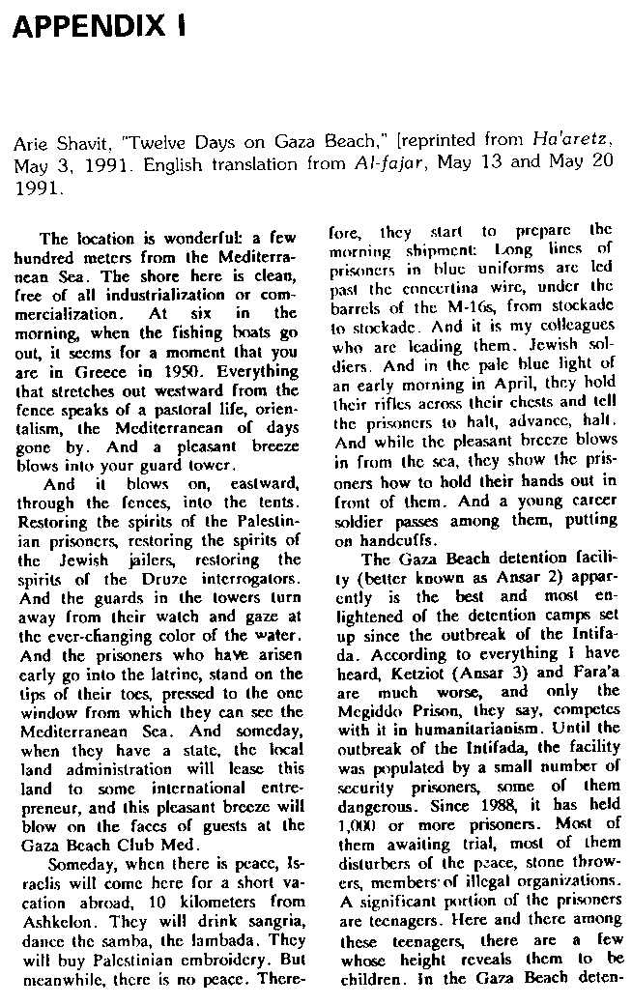
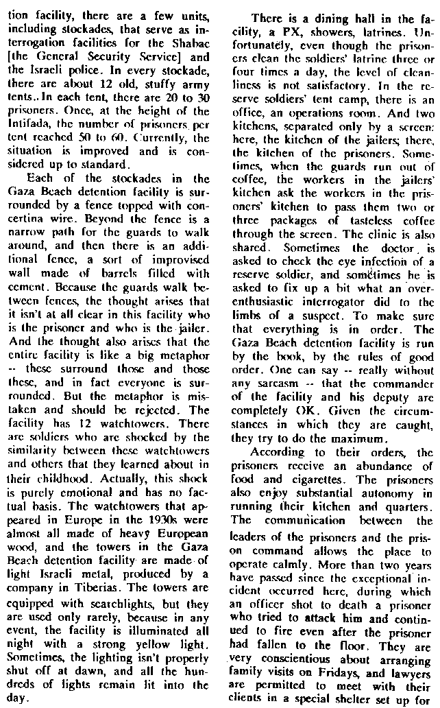

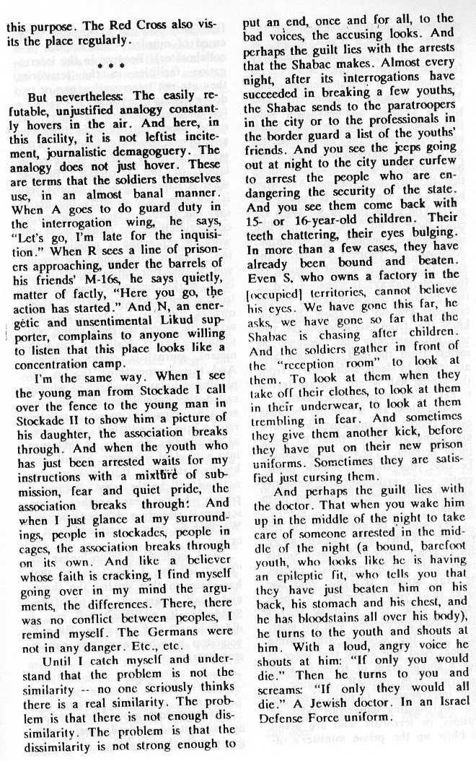

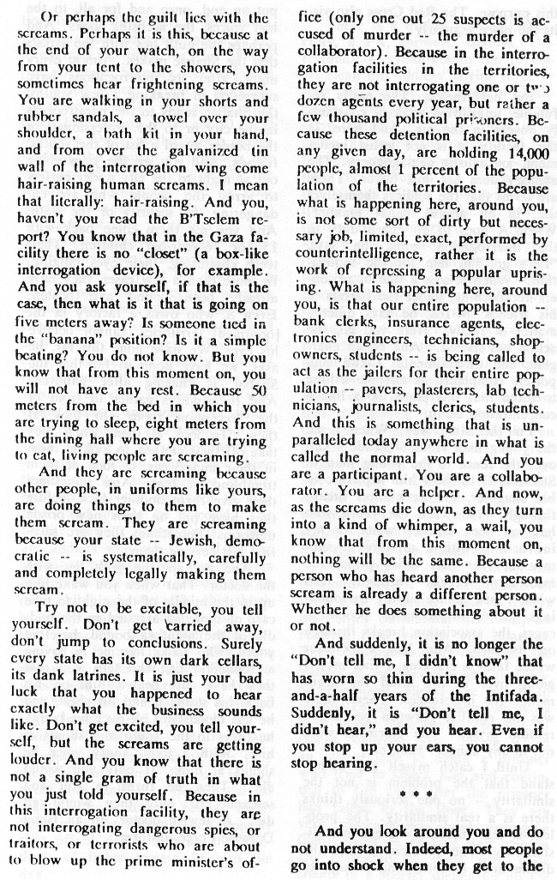

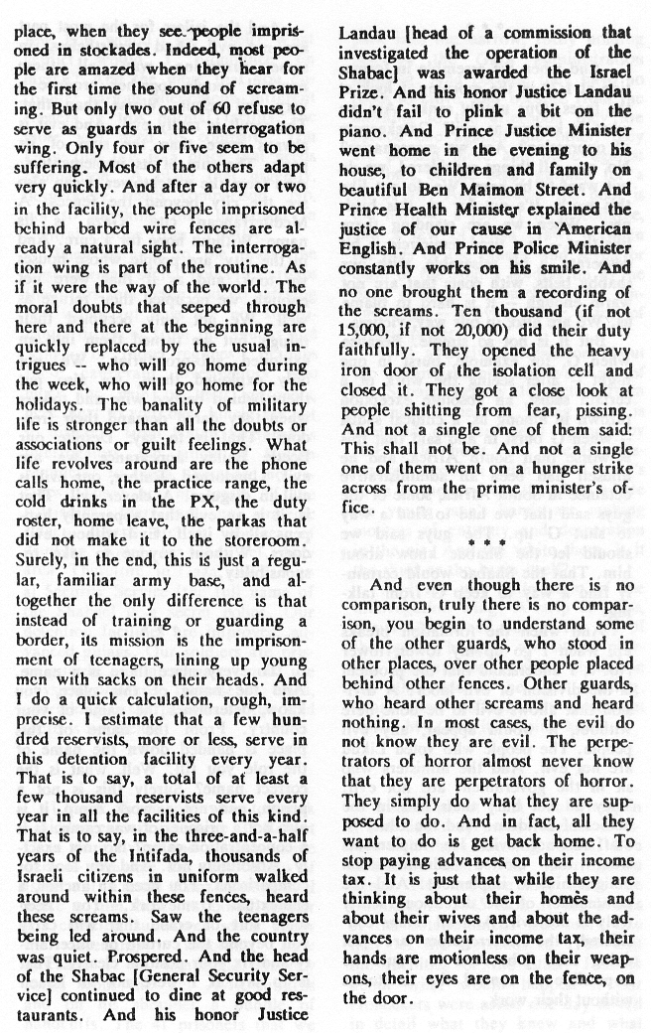

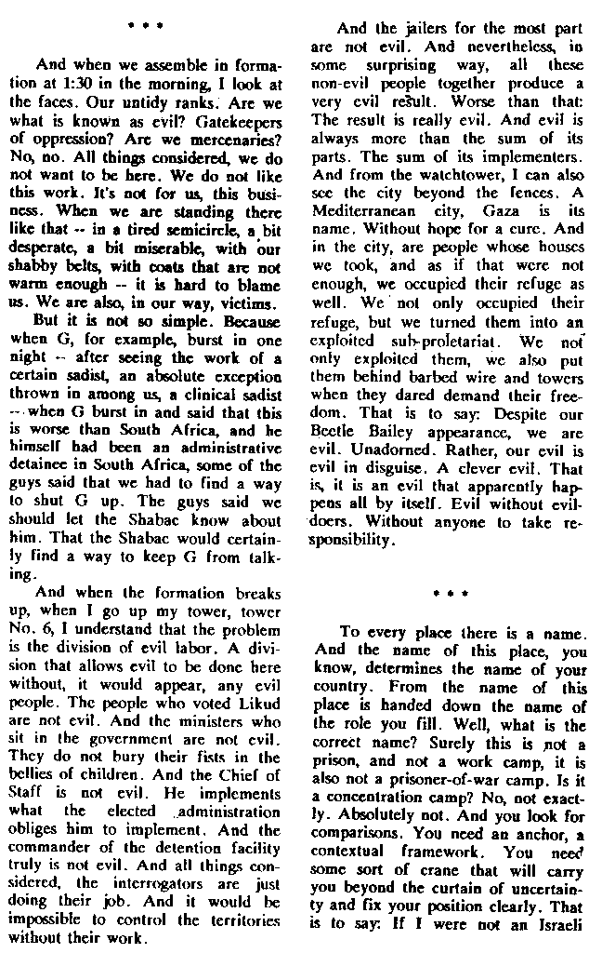

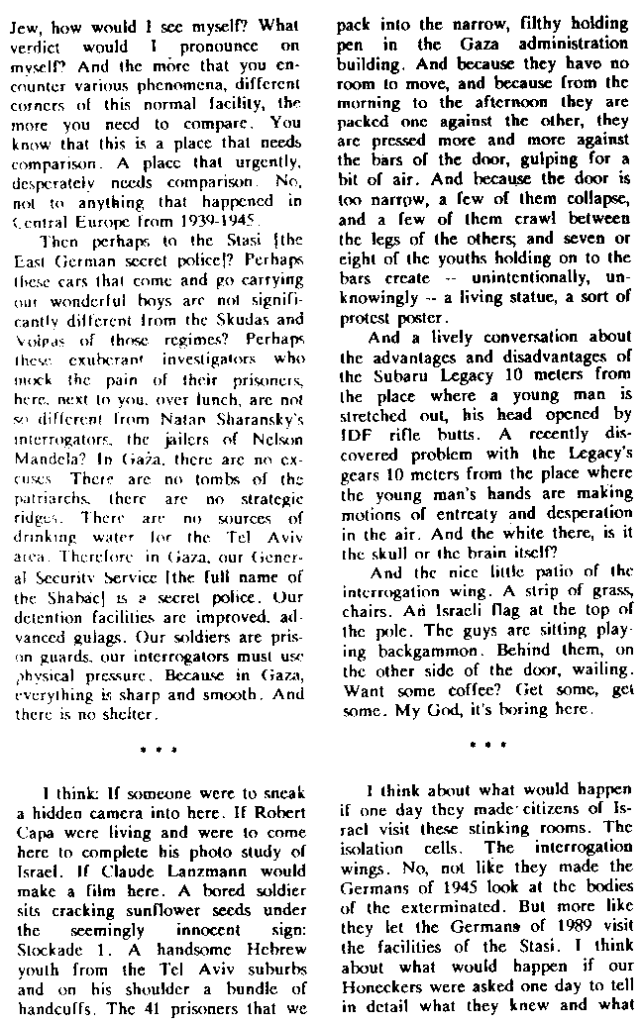

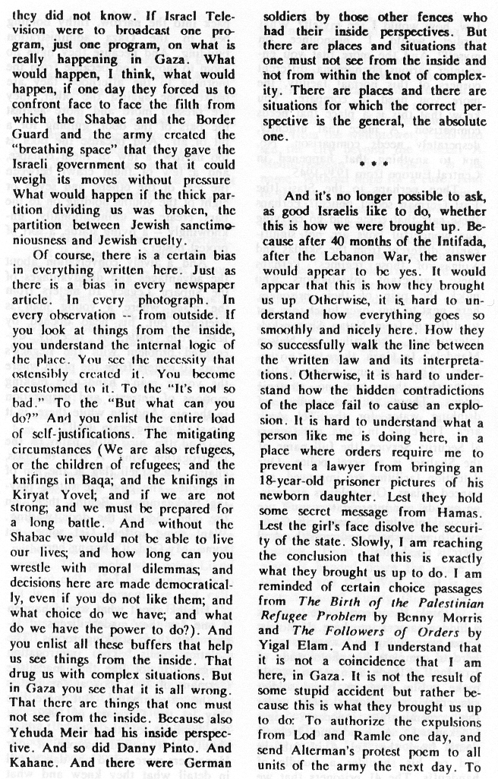

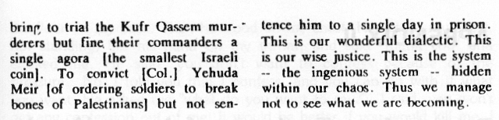

APPENDIX II: Extracts from Testimony of Ayman 'Awad to IDF Inquiry

Aiman 'Abd al-Hamid Nafa 'Awad, I.D. # 080769706, gave testimony to Maj. Gen. Vardi on May 26, 1991. He described his arrest and detention, and presented medical documents indicating that he suffered from epilepsy. Following is only a small portion of his testimony, as recorded by Major Efraim Mandelman. 'Awad describes his first interrogation, conducted in Far'ah, when he refused to confess to the accusations made against him by another witness.

Q: Was there a violent response to what you said?
A: The usual beating - and this is not what I'm complaining about.
Q: How long did this interrogation continue?
A: For approximately an hour and a half the first time round. I don't know him, an he didn't know me either. He lives nearby in Atarot, but we don't know each other. They brought us face to face. The interrogator sat, with me by his side, and the witness next to us. Ask him, said the witness, do it one-two-three, that at 6:30, I threw a stone. But he did not even know my name. Afterwards, it turned out that the interrogator told me that he had to get me to confess. It turned out that this was regarding Heiman 'Abd al-Hamin, not Hamid. I told the interrogator that I was Hamid, and not Hamin, and the interrogator told me that he had also said Hamid. The interrogator removed the witness and beat him - slaps. I said, accept what I say, it's impossible. you want to kill me? Kill me, but don't make me confess to something that I didn't do and isn't logical. The interrogator said, I am telling you that you will confess to this. And I said that I would not confess. The interrogator got angry, and I said that charge they were accusing me of did not make sense. He tied my hands behind my back, after an interrogation during which I was sometimes handcuffed, sometimes not, covered my eyes, brought a wooden stick, and began hitting me in the head with the wooden stick.
Q: A thick stick? thin?
A: I saw the stick, since the interrogator brought it to me before he covered my eyes, and it was a mop stick. He threw me onto the ground and beat me with the stick, sharp blows, while I was lying on the floor on my back. Then he stood on my chest. He sat on my chest, not standing, but his hand on my throat, and said "thank you" and choked me. He said "you don't want to confess because of the pressure - No. I told you that I confess, and you can do with it what you want. He asked me "what do you want to say?" I said, you won't get any confession out of me. It would be better if you would kill me. I was still on the floor, three interrogators in uniform violently closed my eyes, lifted me up, and beat me everywhere, with their hands, without a stick, all three. There is a table like the table we are sitting at - an office table. They lifted me up, the three, and kicked me, and when they lowered me, they took off my blindfold, and asked again, do you want to confess, and continued beating me, including the interrogator, Abu Hanjar, and I fainted, and do not know what happened to me. I woke up in the infirmary in Far'ah - there were maybe four doctors there, not from the same prison actually. I slept on the bed and I woke up.
Q: Do you know how long you slept?
A: Apparently I was unconscious for one half hour. My clothes were full of blood from the blow on the head. The witness [he shows his head, pointing to a sign on his forehead to the examining officer and the translator. It was explained to him that today it is difficult to see the mark - that there was something but it was hard to make out by now.] My pants were torn, and the shirt, which had blood on it, they took it off. I had three shirts in jail - apparently I wore more than one - they let me go, and put me in room number 10. I felt like something was wrong - I was dizzy, I didn't want to eat, I sat in the room for two days. On the third day [he explains that room number 10 is a big lockup], with three or four others with me, [and repeated] on the third day I sat, trembling all over. I had something like an attack - a condition like epilepsy. I urinated in my pants, my tongue stuck out, I bled from the lip, I sat on my mattress, I wanted to get up, and I fell, I woke up, and I saw many army people and interrogators arround me, as well as the four guys who were with me. They poured water on me. I was not myself. I was dazed because I didn't know what had happened to me. They let me rest, brought me to jail - to the Far'ah Jail. Before they took me there, they brought me to the doctor. The doctor examined me, and I understood from him, from what he said, that it would be better if they took me to the hospital, but I was taken to jail, and afterwards it began happening to me all the time, that I would faint - the same fainting condition - epilepsy (as the witness defined it) - would happen every day or two. The prison director took me to the kitchen, and said "it would be better for me to be there..."
Q: Was this at the initiative of the prison director?
A: They guys told the prison director, and he did it. I didn't ask...
Q: Was he interrogated after the incident, and after he spoke with the lawyer?
A: Since the incident I have not been interrogated. They were very scared, and didn't harm me. They knew that every time I would fall. I was in prison for four months.
Q: When was that... in the winter, summer?
A: It was around the month of June. I'll come up with the date at a later occassion.
Q: Tell about the second incident.
A: I'll tell you about another, worse incident. In June 1988, I was arrested in my home in Ramallah, at night, with two friends who were in their homes. They put us in Ramallah, in a tent, and on the second day, they transferred us to Dhahriyyah. They knew that I had a problem in the head, epilepsy, and said that they don't accept it, and returned me to Ramallah. On the third day, they took me from Ramallah to detention in Jerusalem. In detention as well, they refused to receive me, and returned me to Ramallah, and on the same day at around 3:00 or 4:00, they took me to Dhahriyyah again, and there they refused to receive me, and when they took me back, they put me in the Hebron post office for detention, in cabins, in this wooden house. There were all kinds of people there. I sat there for two days, and up to that point the whole ordeal - back and forth from jail to jail, 6, six days, and then they took me again to detention in Jerusalem. Before they transferred me to detention [in] Jerusalem, they took me to Ramallah, and I understood that the one responsible for the prison said to them 'Take him to Dhahriyyah. I am writing a letter to authorize taking him.' They took me there, and didn't accept me. The soldiers who were with me got very angry, since usually, when they take someone to Dhahriyyah they go to sleep, and now, when they understood that they need to take me back, they got angry, cursed, and began beating me. Two of the four or five soldiers beat me - they beat me with their fists. They put me in Hebron, and on the same day they called Ramallah, and said that they should take me to detention in Jerusalem - Moscobiyya - and there they would accept me. I hadn't eaten enough food for two or three days. I ate a piece of bread in the morning, and that's all. I went to jail in Jerusalem, and I was exhausted. They put me there.
Q: In the lockup?
A: In a room in Moscobiyya - not a lockup. When I was inside, there were policemen milling around. They told me, 'Stand on one foot' and also the man in civilian clothes. There was one in military uniform, [who] asked me 'why did you come here?' I said 'I don't know why.' They told me 'stand on one foot.' I said that I can't. For three days I ate almost nothing, and I am very tired. There are cement chairs. They told me to sit on the chair. I sat for a few hours. I asked for water to drink. He told me to shutup. I told him that I wanted to drink. He said to me 'You don't want to drink.' And a policeman, not an officer, came in, beat me up a bit. I sat on the floor. He told me to do it. And when he went out, before he shut [the door], he said "I want to fuck you." I told him that the things were wrong. He kicked me in the back - the policeman - near the belt [as the witness indicated]. I fainted. I don't know what happened. I woke up in room number 14 in Moscobiyya. There were some guys there. I lay down on a concrete bed, on which there is a mattress. Approximately 20 Arab detainees. I asked them where I was. They told 'you're in jail' and asked me how I was. I understood from them that I had been unconscious on the bed for two hours, and they gave me an injection in the rear - according to what they said. I wanted to get up, and I couldn't at all. I felt as if I were paralyzed. My leg was extended outwards. I wanted to get off the bed and couldn't. I managed to move my hands a bit. I started crying. I asked them what happened to me. They said it would be alright. Every day the medic came to me, and gave me the last medicine - Dentoin - I had a whole bottle that I had taken from home, and gave me some of his medicine too, for my back. I don't know what sort of medicine.
Q: Did you have an injury in your back?
A: Only pain. Every day it was worse, stronger pain - a screamed and all the rooms heard me. I shouted from pain. The guys submitted a complaint to the person responsible, that they should take me to the hospital, and I refused. The other prisoners held a hunger strike on my behalf, so that they'd take me, and I still couldn't move. About three days after the blow, they took me to the infirmary with six carrying me on their hands [so he would be straight on the mattress on which he lay]. If there was something under me, I would start to scream, and also, when they took me I screamed from pain, because of the movement. They put me on the floor with a mattress, and everyone went out. The prisoners were on a walk in the courtyard, there were four policemen, and there was no doctor; there was a medic. They asked me what was the matter. I explained to them what happened, and they all began laughing. The medic was wearing a medic's white suit. The medic also laughed. They told me 'you're a liar. We're going to take you out and you'll walk regular.' I said that I hope so, but I can't. They started torturing me. They lifted up my leg, drew my legs to my chest…I began to scream. This is what the police did. I felt like my back was broken. All of my friends outside heard me, knew they were beating me, and also began to protest, shouting "Police, officer." The person responsible for the policemen came, an officer. Four guys came, four prisoners came and took me to room 14, again on the mattress, the same system. Afterwards they brought me medicine – aspirin – only when I screamed, three or four pills per day. And I would always urinate in my clothes. In the beginning I could move my hands, and afterwards, I couldn't move my hands and fingers either. It was like I was paralyzed – I couldn't even move my head.

APPENDIX III: Charge Sheet No. 1 against the Police Investigators in Jerusalem

1. On December 16, 1989, during the night hours, Isama'il al-Ghul (hereinafter "Isma'il") was arrested by the Jerusalem police, in a suspected attempt of murder of a man named 'Abdallah Mash'al from Ras al-'Amud. When he was brought to the division for interrogation, he was also interrogated on suspicion of murdering Khalil Qara'in from Jabel Mukaber, and for throwing Molotov cocktails at the Jaber family's home in Ral al-'Amud. Accused number 3 was apppointed as head of the team investigating the said crimes.

2. When he was arrested, during the night, on and off, Isma'il was beaten with a stick on the soles of his feet by two interrogators from the division, whose identity is unknown to the prosecutor. The interrogators also poured cold water on Isma'il.

3. On the Morning of December 17, 1989, a confession was taken from him, under the influence of beatings, by accused number 5. In this confession, Isma'il confessed to the crime of attempted murder, which he did not committ, attributed to him by accused number 5.

4. On December 20, 1989, Isma'il was taken out to reconstruct the crime of the attempted murder and throwing the Molotovs. The interrogators appointed for the reconstruction were accused numbers 2, 3, 4, and 7.

5. a. Accused numbers 2, 3, 4, and 7 saw that Isma'il was not prepared to reconstruct the details of the crime, and despite this, accused 4 and 7 instructed Isma'il to point to the places where the deeds of the crime had been committed.

b. Accused number 4 wrote a report on the transportation to and indication during the reconscruction, but the report did not reflect the actual process of the reconstruction.

c. The abovementioned accused did not write, either in the report on the transportation and indication about the reconstruction or in any other report, or in the investigations file, about the lack of correlation in the reconstruction between the details of the crimes attributed to Isma'il.

d. The aforementioned accused denied knowing of the difficulties which had arisen during the reonstruction with Isma'il.

6. a. On December 27, 1989, Isma'il was beaten during an additional interrogation in the Minorities Division offices, by interrogators whose identity is unknown to the prosecutor, and this was after his head was covered.

b. After some time, accused number 4 entered the room, aware that Isma'il was being beaten at that moment, removed his headcovering, and took an additional confession from him, in which Isma'il confessed to deeds he did not commit.

c. Before the said confession was taken, accused number 4 demanded that Isma'il adjust the details of the confession to the facts that accused number 4 knew, which he gave to Isma'il in order to correct the confession in accordance.

d. Accused number 4 even threatened Isma'il that if he did not correct the confession as required, they would return him to those who had beaten him.

e. Following the threats of accused number four, Isma'il wrote, in his handwriting, a confession, containing "corrections" of the details which he had given in the first confession on December 17, 1989.

7. a. On December 28, 1989, Isma'il was interrogated by accused number 4. During the interrogation, Isma'il confessed, in a hand-written confession, to the murder of Khalil Qara'in, which he did not commit.

b. Isma'il noted certain items in the confession regarding the instructions he had received from accused number 4. Isma'il confessed, as stated, following threats by accused number 4, and after he had threatened him, illegally, that if if he did not confess to the aforementioned crime, he would be returned to those who had beaten him.

8. a. On January 1, 1990, accused number 4 appeared in the Jerusalem Magistrates Court before the Honorable Judge D. Heshin, in order to request an extension of detention for Isma'il for the purposes of interrogation.

b. During the trial, accused number 4 testified that the confessions taken from Isma'il were taken from his good free will, that the details given in his confession were his words and not the words of his interrogators, and that they did not use violence against him.
Accused number 4 knew at the time that he had testified, as said, that his testimony was false regarding an essential item regarding the manner in which he had testified.

9. a. On January 16, 1990, Chief Superintendent Yitzhak Cohen, Head of the Office of Criminal Investigations, Jerusalem Region, wrote to the Military Advocate General, requesting that the latter press charges against Isma'il, 'Ali, and Munir Ghul (henceforth "the suspects"), of the crime of throwing Molotov cocktails at Majed Jaber's house.

b. Following the said request, accused number 2 held a conversation with the Military Prosecutor, Captain Ron Shapira (henceforth "the prosecutor"), and requested that he charge the suspects regarding only the crime of throwing the Molotov cocktails.

c. During the conversation described above, accused number 2 did not alert the prosecutor to the difficulties in the evidence which emerged in Isma'il's confession, and in the reconstruction which he enacted, and did not inform him that in the confrontation (detailed in charge no. 5) Isma'il had retracted his confession regarding all the crimes attributed to him.

10. a. In the deeds described above, accused number four blackmailed Isma'il with threats, by illegally threatening to inflict on him bodily harm if he would not confess to the crimes attributed to him, in order to motivate him to confess. As a result of the accused's threats, Isma'il confessed to the crimes attributed to him.

b. In addition, accused number 4 fabricated evidence, in the deeds listed in item 6 above.

c. In the deeds described in item 8 above, accused number 4 gave a false testimony, in essential items regarding the question discussed during the procedure.

d. In the deeds described above in items 4 and 5, accused numbers 2,3,4, and 7, fabricated evidence, and even knowingly used this fabricated evidence, with the sole intention of misleading the judiciary. On the other hand, the abovementioned accused individuals purposefully concealed evidence with the intention of obstructing judicial procedure.

There are four additional charge sheets regarding the interrogation of Isma'il al-Ghool's family members, who were interrogated in a similar fashion. The sixth charge sheet describes how a 13-year-old boy was interrogated on suspicion of membership in a forbidden organization. The other charges describe similar accusations of attack, blackmail under force, sabotage, and injury in severe circumstances, by throwing stones and giving false testimony [?]. The interrogation methods described are similar to those described in B'Tselem's 1991 report.

The case is still being heard in the Jerusalem District Court. Meanwhile, on the instructions of the Chief of Police, three of the policemen involved have been suspended and five others transferred to jobs not related to investigation work.

. Report of Commission of Inquiry into Methods of Investigation of the General Security Service (GSS) Regarding Hostile Terrorist Activity. (Jerusalem: State of Israel, October 1987).
. For a more detailed analysis of the range of Israeli public reaction to the B'tselem Report, see: Stanley Cohen, "Talking About Torture in Israel," Tikkun, Vol.6, No.6, November/December 1991.
. See, for example, Yizhar Be'er "Not Very Moderate Physical Pressure," Ha'aretz, March 22, 1991.
. See especially Ha'ir (Tel Aviv) and Kol Ha'ir (Jerusalem), March 22, 1991.
. See, for example, B. Michael, "Just Doing Their Job," Ha'aretz, March 22, 1991; Editorial, Ha'aretz, March 25, 1991; Ran Kislev, "From Moderate Physical Pressure to the B'tselem Report," Ha'aretz, March 28, 1991; Tom Segev," The Happening in Three Reports," Ha'aretz, April 4, 1991; Haim Baram,"Torture" Kol Ha'ir, April 4, 1991; Gadi Ytziv, "B'tselem the patriots," Al Ha-mishmar, April 4, 1991.
. Dov Goldstein,"I Demand to Know," Ma'ariv, March 31, 1991.
. In response, B'tselem responded (i) that interviewees were promised anonymity to protect them from further harassment; (ii) that in 14 names were revealed and detailed complaints had already been submitted to the authorities and (iii) that there is only one case on record - the killing of Khaled Sheikh 'Ali [see Sec.4(f)] - where abuses during interrogation had resulted in criminal prosecution.
. Dan Margalit, Ha'aretz, March 31, 1991. Margalit has repeatedly attacked any criticism by human rights organizations either of the GSS or the Landau Commission; see articles in Ha'aretz, August 31, 1991 and September 20, 1991.
. Vered Lamm, "It Does Bother Them," Ha'aretz, May 6 1991. These 11 interviews are followed by a discussion with one of the authors of our Report, Daphna Golan, about the credibility of our sources. For further hostile reaction, see editorial Jerusalem Post, May 5, 1991 and our reply June 6, 1991.
. Yediot Achronot, May 3, 1991. See also Tom Segev, "Justice Landau's Letter," Ha'aretz, May 10, 1991.
. In April 1991, Justice Landau also sent a letter to Amnesty International to express his "personal protest" against a statement by the organization in January 1991 to the U.N. Commission on Human Rights in Geneva. He rejected any implication that the Commission authorized the use of torture and points to the Commission's explicit emphasis that "pressure must never reach the level of physical torture or maltreatment of the suspect or grievous harm to his honour which deprives him of human dignity." He also repeated his allegation that "false complaints" and "gross exaggerations" by suspects are "...common as part of a systematic campaign conducted by terrorist organizationss against the GSS." For further reference to reactions by Amnesty and other international human rights organizations, see Sect. 5(b).
. May 7, 1991; available from B'tselem.
. Arie Shavit, "Twelve Days on Gaza Beach," Ha'aretz, May 3, 1991.
. See especially, Gidon Levi,"Light on the Shin Bet," Ha'aretz, May 16, 1991. The general issue of public control over the GSS - in the wake of the B'tselem Report and other exposures - is dicussed in Ron Ben-Yishai "The Shabak Comes out of the Closet," Yediot Ahronot, June 21, 1991 and Tuva Tzimuki, " GSS: Top Secret Group." Davar, September 17 1991.
. Shlomo Gazit, "Under the Black Flag," Ha'aretz, September 22, 1991; see also his earlier similar article "The B'tselem Report: A Worthless Blessing," Ma'ariv, May 24, 1991.
. The allusion is to an earlier article by Nissim Kalderon, "The Person in the Library," Ha'aretz, September 17 ,1991. This article imagines the effect in ten years time of sitting in a library reading the B'tselem report - and trying to understand how the atrocities recorded were carried out by the Shabak, with the complicity of a Minister, the permission of a Supreme Court Judge and the knowledge of the Israeli public.
. Independent, March 22, 1991, Times, March 22, 1991) and Daily Telegraph, March 22, 1991.
. Aryeh Neier, "Watching Rights," The Nation, June 24, 1991, p.841.
. Arie Shavit, "On Gaza Beach," New York Review of Books, July 18, 1991.
Al Hamishmar, May 26, 1991
Ha'aretz, April 25, 1991; Hadashot, April 25, 1991. The MK's who are signatory to the letter are Haim Ramon, Lova Eliav, Avraham Burg, Amir Peretz, Yossi Beilin, Shulamit Aloni, Yossi Sarid, Dedi Tzucker, Ran Cohen, Mordechai Warshuvski, Yair Tsaban, Hussein Farres, Amnon Rubinstein, and Avraham Poraz.
Yediot Ahronot, June 19, 1991.
Ha'aretz, May 12, 1991.
IDF Press Release of August 13, 1991.
Letter of Justice Minister Dan Meridor, May 4, 1991, No. 337.
Meridor to Kretzmer, ibid.
Letter of Rachel Sucar, Deputy to the State Attorney, to Advocate Tamar Peleg, Association for Civil Rights in Israel. December 22, 1991.
Ha'aretz, May 16, 1991.
Haaretz, May 24, 1991.
HCJ 2581/91.
The Israeli media coverage, November 11, 1991 of the respondents' reply, concentrated almost completely on this point; see for example "Head of the GSS: 'Moderate Physical Pressure' Needed Even More Today" Ma-ariv, November 11, 1991.
Letter from Amnesty International (August 16, 1991) to Public Committee Against Torture in Israel.
Twenty-four other countries out of the 54 State Parties to the Convention have declared that they do not recognize the competence of the Committee under Article 22; only 12 have declared under Article 28 that they do not recognize the competence of the Committee at all.
. Letter of February 9, 1992, from Legal Advisor to Ministry of Foreign Affairs in reponse to B'tselem request for information about Israeli ratifications of human rights conventions.
This policy (the subject of complex debate in international law) was formally confirmed by Robi Sabel, Legal Advisor of the Ministry of Foreign Affairs, (February 9, 1992) in a reply to our enquiry.
In this context, we should note the frequent practice of transferring East Jerusalem residnets suspected of seucirty offenses to the West Bank for interrogation, thus depriving them of the protections of Israeli law. This happened, for example, in the case of Mustafa 'Akawi.
HCJ 346/92
The two other sections of the petition address the limitation of detention until charges are pressed, and until the conclusion of the prisoners trial.
. Judgement delivered August 15, 1991 by Supreme Court acting as Court of Criminal Appeals in the matter of A.B. and C.D. appellants, versus the State of Israel, respondents (Cr.A. 532/91). For relevant commentary, see, for example, Ha'aretz September 5, 1991 and Ran Kislev, "The Hatred is Being Built up," Ha'retz September 11, 1991.
. The Knesset Debate, January 22, 1992 includes M.K. Gozansky's case for this special addition to the Penal Law and the reply by the Minister of Justice to the effect that this would be redundant given Israel's stated opposition to torture and the adequacy of existing legislation. The preliminary reading passed by 10 to 9 votes.
Rachel Sucar to Tamar Pelleg-Sryck, February 5, 1991, No. 5484.
Phone call to Jerusalem District Attorney on March 9, 1992.
? Israel and the Occupied Territories: The Military Justice System in the Occupied Territories: Detention, Interrogation and Trial Procedures. (London: Amnesty International, July 1991). The Report - particularly its claim that torture and ill-treatment is a "matter of routine" - was extensively covered in the Israeli press. See especially, Davar, Jerusalem Post and Hadashot, July 30, 1991.
Ibid. p. 58.
Ibid, p. 45.
Ibid, p. 64.
.Critique: Review of the U.S. Department of State's Country Reports on Human Rights Practices for 1990: Israeli-Occupied Territories (New York: Lawyers Committee for Human Rights, 1991)
. Ibid p. 2.
Israel's Use of Electric Shock Torture in the Interogation of Palestinian Detainees (Jerusalem: PHRIC, December 1991).
See Doron Me'eri, Hadashot, February 16, 1992 and February 24, 1992. See also Tom Segev, "A Report from Hebron, Ha'aretz, January 3, 1992.
"Human Rights Conditions inthe Israeli-Occupied West Bank and Gaza Strip in 1991" from Human Rights Watch World Report, 1991 (New York, Human Rights Watch, 1992).
Ibid, p.520. Later in 1992, Middle East Watch will also be issuing a special report on interrogation methods in Israeli-Occupied Territories.
See "Backgrounder:" State Department Country Reports on Human Rights Practices for 199l: Israel and the Occupied Territories (U.S. Information Service: American Consulate General, Jerusalem).
Ibid, p. 4.
Ibid, p. 5.
Ariela Ringel Hoffman,"Interrogation Room," Yediot Ahronot, November 22, 1991.
The article also refers to a working distinction within the GSS between interrogation methods that are "Landau minus" and those that are "Landau plus."
. Hadashot, February 14, 1992 and February 24, 1992.
In a case reported in August 1991, a Bir Zeit student from Gaza was badly beaten by a group of collaborators in the Ramallah Ministry Headquarters. He was placed in a room on the orders of the GSS interrogators and burned by the collaborators 21 times on his arms, neck and face. [Detailed testimony and photographs available from Human Rights Action Project, Bir Zeit University.]
On October 31, 1991, the Israel Prison Service Spokesperson confirmed receiving the letter.
Trial in file 275/91 in Gaza, November 13, 1991.
Gaza Military Court, File No. 275/91, November 12, 1991.
Jaber's complaints have been forwarded by PCATI to the Minister of Justice.
Hebron Court, File No. 69/92.
We again draw attention to the practice of depriving Palestinian residents of East Jerusalem of their legal rights by transferring them for detention and interrogation to the West Bank. This is deliberate policy to allow interrogation to continue for 18 days without the suspect's appearing before a judge, rather than the 48 hours allowed by Israeli law which applies in East Jerusalem. Only in cases like 'Akawi's do the consequences of this policy become publicly known.
'Akawi died before he was brought to trial, and therefore, this accusation has no legal basis. He was arrested during a wave of arrests of persons suspected of membership in the Popular Front for the Liberation of Palestine (PFLP). This was 'Akawi's second arrest. In 1985, he was sentenced to 10 months' imprisonment for membership in the Popular Front. Because of his imprisonment, he quit medical school, where he was in his third year.
Ha'aretz, February 13, 1992.
Ha'aretz, February 14, 1992.
Ha'aretz, February 13, 1992. The context suggests that "disciplinary and administrative aspects" refers to the Landau Commission guidelines.
Ha'aretz, February 13, 1992
The issues raised by the 'Akawi case, especially the total unaccountability of the GSS, are well discussed by Danny Rubinstein in "A Supreme and Unaccountable Authority." Ha'aretz, February 7, 1992.

